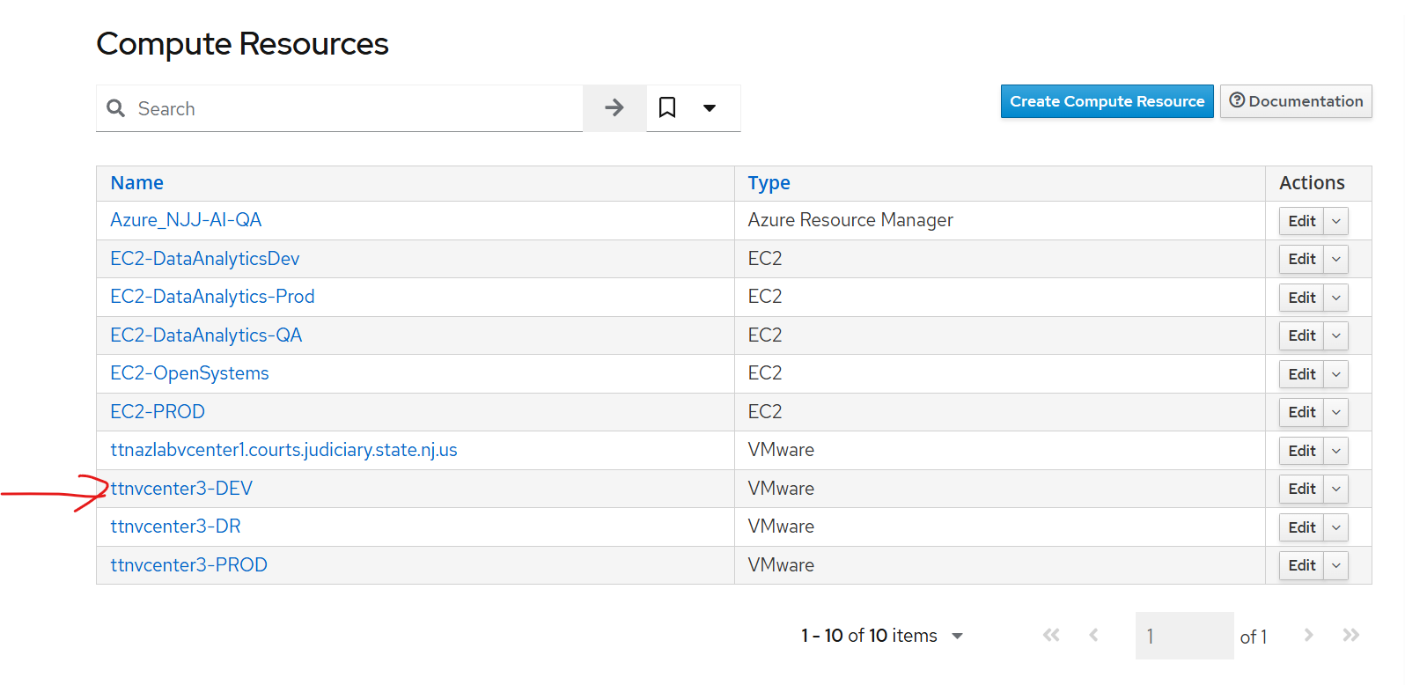
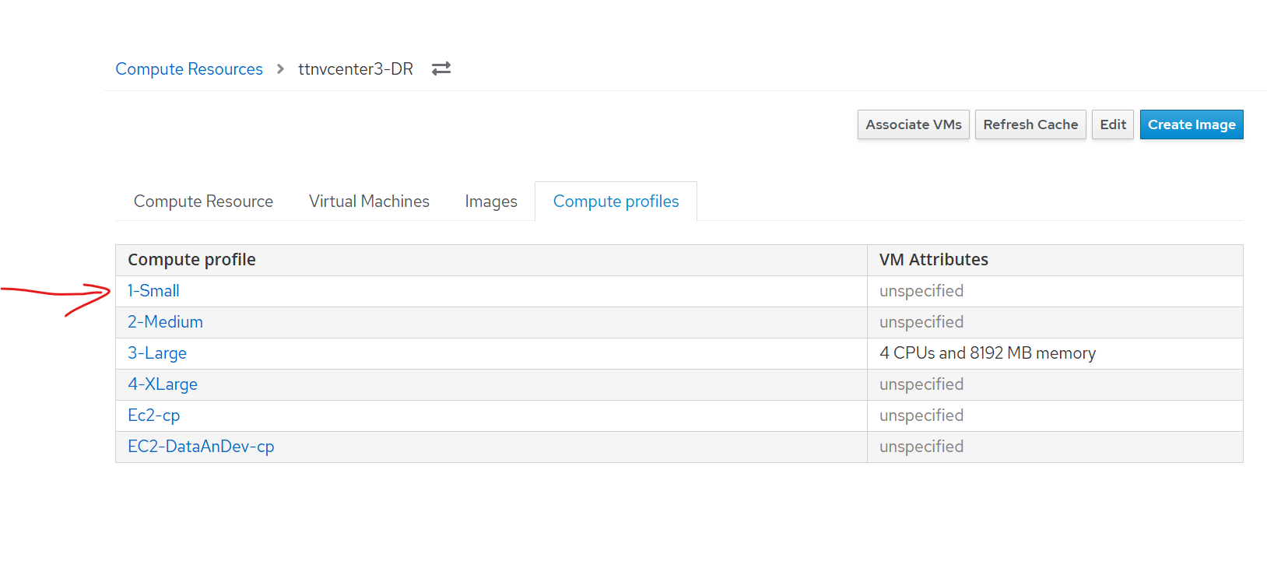
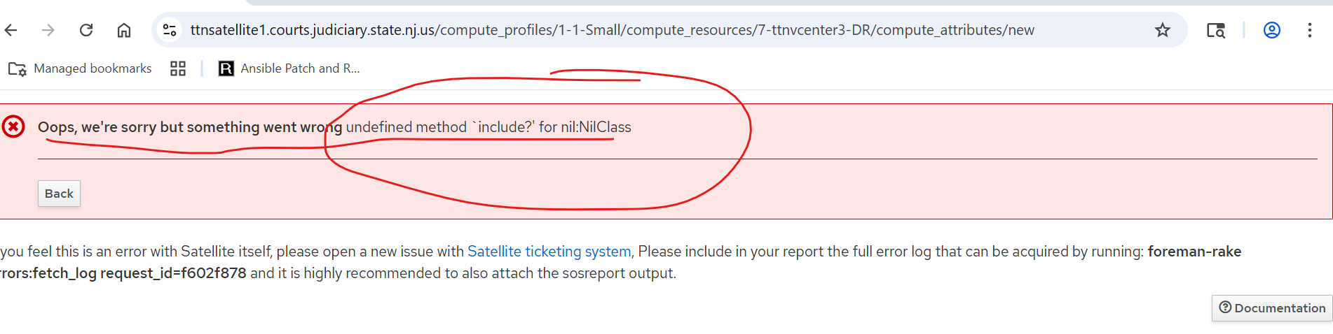

[root@ttnsatellite1 /home/admin.bhandarkar]# foreman-rake errors:fetch_log request_id=f602f878
Foreman version: 3.12.0.8
Plugins:
- foreman-tasks 9.2.3
- foreman_ansible 14.2.3
- foreman_azure_rm 2.3.0
- foreman_bootdisk 21.2.3
- foreman_discovery 24.0.2
- foreman_google 2.0.1
- foreman_leapp 1.2.3
- foreman_openscap 9.0.5
- foreman_puppet 7.0.0
- foreman_remote_execution 13.2.8
- foreman_rh_cloud 10.0.6
- foreman_templates 9.5.1
- foreman_theme_satellite 13.3.5
- foreman_virt_who_configure 0.5.23
- foreman_webhooks 3.2.3
- katello 4.14.0.13

2025-08-01T09:14:51 [I|app|f602f878] Started GET "/compute_profiles/1-1-Small/compute_resources/7-ttnvcenter3-DR/compute_attributes/new" for 10.0.12.204 at 2025-08-01 09:14:51 -0400
2025-08-01T09:14:51 [I|app|f602f878] Processing by ComputeAttributesController#new as HTML
2025-08-01T09:14:51 [I|app|f602f878] Parameters: {"compute_profile_id"=>"1-1-Small", "compute_resource_id"=>"7-ttnvcenter3-DR"}
2025-08-01T09:14:52 [I|app|f602f878] Rendered compute_attributes/new.html.erb within layouts/application (Duration: 221.2ms | Allocations: 166199)
2025-08-01T09:14:52 [I|app|f602f878] Rendered layout layouts/application.html.erb (Duration: 221.3ms | Allocations: 166253)
2025-08-01T09:14:52 [W|app|f602f878] undefined method `include?' for nil:NilClass
2025-08-01T09:14:52 [I|app|f602f878] Backtrace for 'undefined method `include?' for nil:NilClass' error (ActionView::Template::Error): undefined method `include?' for nil:NilClass
f602f878 | /usr/share/gems/gems/fog-vsphere-3.7.0/lib/fog/vsphere/requests/compute/get_virtual_machine.rb:40:in `get_vm_by_name'
f602f878 | /usr/share/gems/gems/fog-vsphere-3.7.0/lib/fog/vsphere/requests/compute/get_virtual_machine.rb:25:in `block in get_vm_ref'
f602f878 | /usr/share/gems/gems/fog-vsphere-3.7.0/lib/fog/vsphere/requests/compute/get_virtual_machine.rb:25:in `map'
f602f878 | /usr/share/gems/gems/fog-vsphere-3.7.0/lib/fog/vsphere/requests/compute/get_virtual_machine.rb:25:in `get_vm_ref'
f602f878 | /usr/share/gems/gems/fog-vsphere-3.7.0/lib/fog/vsphere/requests/compute/list_vm_nvme_controllers.rb:12:in `list_vm_nvme_controllers_raw'
f602f878 | /usr/share/gems/gems/fog-vsphere-3.7.0/lib/fog/vsphere/requests/compute/list_vm_nvme_controllers.rb:6:in `list_vm_nvme_controllers'
f602f878 | /usr/share/gems/gems/fog-vsphere-3.7.0/lib/fog/vsphere/models/compute/server.rb:297:in `nvme_controllers'
f602f878 | /usr/share/foreman/app/views/compute_resources_vms/form/vmware/_base.html.erb:64:in `_app_views_compute_resources_vms_form_vmware__base_html_erb__4072592632394974606_3189060'
f602f878 | /usr/share/gems/gems/actionview-6.1.7.8/lib/action_view/base.rb:247:in `public_send'
f602f878 | /usr/share/gems/gems/actionview-6.1.7.8/lib/action_view/base.rb:247:in `_run'
f602f878 | /usr/share/gems/gems/actionview-6.1.7.8/lib/action_view/template.rb:154:in `block in render'
f602f878 | /usr/share/gems/gems/activesupport-6.1.7.8/lib/active_support/notifications.rb:205:in `instrument'
f602f878 | /usr/share/gems/gems/actionview-6.1.7.8/lib/action_view/template.rb:345:in `instrument_render_template'
f602f878 | /usr/share/gems/gems/actionview-6.1.7.8/lib/action_view/template.rb:152:in `render'
f602f878 | /usr/share/gems/gems/actionview-6.1.7.8/lib/action_view/renderer/partial_renderer.rb:285:in `block in render_partial_template'
f602f878 | /usr/share/gems/gems/activesupport-6.1.7.8/lib/active_support/notifications.rb:203:in `block in instrument'
f602f878 | /usr/share/gems/gems/activesupport-6.1.7.8/lib/active_support/notifications/instrumenter.rb:24:in `instrument'
f602f878 | /usr/share/gems/gems/activesupport-6.1.7.8/lib/active_support/notifications.rb:203:in `instrument'
f602f878 | /usr/share/gems/gems/actionview-6.1.7.8/lib/action_view/renderer/partial_renderer.rb:280:in `render_partial_template'
f602f878 | /usr/share/gems/gems/actionview-6.1.7.8/lib/action_view/renderer/partial_renderer.rb:271:in `render'
f602f878 | /usr/share/gems/gems/actionview-6.1.7.8/lib/action_view/renderer/renderer.rb:81:in `render_partial_to_object'
f602f878 | /usr/share/gems/gems/actionview-6.1.7.8/lib/action_view/renderer/renderer.rb:27:in `render_to_object'
f602f878 | /usr/share/gems/gems/actionview-6.1.7.8/lib/action_view/renderer/renderer.rb:22:in `render'
f602f878 | /usr/share/gems/gems/actionview-6.1.7.8/lib/action_view/helpers/rendering_helper.rb:38:in `block in render'
f602f878 | /usr/share/gems/gems/actionview-6.1.7.8/lib/action_view/base.rb:273:in `in_rendering_context'
f602f878 | /usr/share/gems/gems/actionview-6.1.7.8/lib/action_view/helpers/rendering_helper.rb:34:in `render'
f602f878 | /usr/share/foreman/app/views/compute_attributes/_compute_form.html.erb:2:in `_app_views_compute_attributes__compute_form_html_erb___4581017520556877749_3189040'
f602f878 | /usr/share/gems/gems/actionview-6.1.7.8/lib/action_view/base.rb:247:in `public_send'
f602f878 | /usr/share/gems/gems/actionview-6.1.7.8/lib/action_view/base.rb:247:in `_run'
f602f878 | /usr/share/gems/gems/actionview-6.1.7.8/lib/action_view/template.rb:154:in `block in render'
f602f878 | /usr/share/gems/gems/activesupport-6.1.7.8/lib/active_support/notifications.rb:205:in `instrument'
f602f878 | /usr/share/gems/gems/actionview-6.1.7.8/lib/action_view/template.rb:345:in `instrument_render_template'
f602f878 | /usr/share/gems/gems/actionview-6.1.7.8/lib/action_view/template.rb:152:in `render'
f602f878 | /usr/share/gems/gems/actionview-6.1.7.8/lib/action_view/renderer/partial_renderer.rb:285:in `block in render_partial_template'
f602f878 | /usr/share/gems/gems/activesupport-6.1.7.8/lib/active_support/notifications.rb:203:in `block in instrument'
f602f878 | /usr/share/gems/gems/activesupport-6.1.7.8/lib/active_support/notifications/instrumenter.rb:24:in `instrument'
f602f878 | /usr/share/gems/gems/activesupport-6.1.7.8/lib/active_support/notifications.rb:203:in `instrument'
f602f878 | /usr/share/gems/gems/actionview-6.1.7.8/lib/action_view/renderer/partial_renderer.rb:280:in `render_partial_template'
f602f878 | /usr/share/gems/gems/actionview-6.1.7.8/lib/action_view/renderer/partial_renderer.rb:271:in `render'
f602f878 | /usr/share/gems/gems/actionview-6.1.7.8/lib/action_view/renderer/renderer.rb:81:in `render_partial_to_object'
f602f878 | /usr/share/gems/gems/actionview-6.1.7.8/lib/action_view/renderer/renderer.rb:27:in `render_to_object'
f602f878 | /usr/share/gems/gems/actionview-6.1.7.8/lib/action_view/renderer/renderer.rb:22:in `render'
f602f878 | /usr/share/gems/gems/actionview-6.1.7.8/lib/action_view/helpers/rendering_helper.rb:38:in `block in render'
f602f878 | /usr/share/gems/gems/actionview-6.1.7.8/lib/action_view/base.rb:273:in `in_rendering_context'
f602f878 | /usr/share/gems/gems/actionview-6.1.7.8/lib/action_view/helpers/rendering_helper.rb:34:in `render'
f602f878 | /usr/share/foreman/app/views/compute_attributes/_form.html.erb:8:in `block (2 levels) in _app_views_compute_attributes__form_html_erb___4199002052073342812_3189020'
f602f878 | /usr/share/gems/gems/actionview-6.1.7.8/lib/action_view/helpers/capture_helper.rb:45:in `block in capture'
f602f878 | /usr/share/gems/gems/actionview-6.1.7.8/lib/action_view/helpers/capture_helper.rb:209:in `with_output_buffer'
f602f878 | /usr/share/gems/gems/actionview-6.1.7.8/lib/action_view/helpers/capture_helper.rb:45:in `capture'
f602f878 | /usr/share/gems/gems/actionview-6.1.7.8/lib/action_view/helpers/form_helper.rb:1004:in `fields_for'
f602f878 | /usr/share/foreman/app/views/compute_attributes/_form.html.erb:7:in `block in _app_views_compute_attributes__form_html_erb___4199002052073342812_3189020'
f602f878 | /usr/share/gems/gems/actionview-6.1.7.8/lib/action_view/helpers/capture_helper.rb:45:in `block in capture'
f602f878 | /usr/share/gems/gems/actionview-6.1.7.8/lib/action_view/helpers/capture_helper.rb:209:in `with_output_buffer'
f602f878 | /usr/share/gems/gems/actionview-6.1.7.8/lib/action_view/helpers/capture_helper.rb:45:in `capture'
f602f878 | /usr/share/gems/gems/actionview-6.1.7.8/lib/action_view/helpers/form_helper.rb:450:in `form_for'
f602f878 | /usr/share/foreman/app/helpers/form_helper.rb:284:in `form_for'
f602f878 | /usr/share/foreman/app/views/compute_attributes/_form.html.erb:1:in `_app_views_compute_attributes__form_html_erb___4199002052073342812_3189020'
f602f878 | /usr/share/gems/gems/actionview-6.1.7.8/lib/action_view/base.rb:247:in `public_send'
f602f878 | /usr/share/gems/gems/actionview-6.1.7.8/lib/action_view/base.rb:247:in `_run'
f602f878 | /usr/share/gems/gems/actionview-6.1.7.8/lib/action_view/template.rb:154:in `block in render'
f602f878 | /usr/share/gems/gems/activesupport-6.1.7.8/lib/active_support/notifications.rb:205:in `instrument'
f602f878 | /usr/share/gems/gems/actionview-6.1.7.8/lib/action_view/template.rb:345:in `instrument_render_template'
f602f878 | /usr/share/gems/gems/actionview-6.1.7.8/lib/action_view/template.rb:152:in `render'
f602f878 | /usr/share/gems/gems/actionview-6.1.7.8/lib/action_view/renderer/partial_renderer.rb:285:in `block in render_partial_template'
f602f878 | /usr/share/gems/gems/activesupport-6.1.7.8/lib/active_support/notifications.rb:203:in `block in instrument'
f602f878 | /usr/share/gems/gems/activesupport-6.1.7.8/lib/active_support/notifications/instrumenter.rb:24:in `instrument'
f602f878 | /usr/share/gems/gems/activesupport-6.1.7.8/lib/active_support/notifications.rb:203:in `instrument'
f602f878 | /usr/share/gems/gems/actionview-6.1.7.8/lib/action_view/renderer/partial_renderer.rb:280:in `render_partial_template'
f602f878 | /usr/share/gems/gems/actionview-6.1.7.8/lib/action_view/renderer/partial_renderer.rb:271:in `render'
f602f878 | /usr/share/gems/gems/actionview-6.1.7.8/lib/action_view/renderer/renderer.rb:81:in `render_partial_to_object'
f602f878 | /usr/share/gems/gems/actionview-6.1.7.8/lib/action_view/renderer/renderer.rb:53:in `render_partial'
f602f878 | /usr/share/gems/gems/actionview-6.1.7.8/lib/action_view/helpers/rendering_helper.rb:45:in `render'
f602f878 | /usr/share/foreman/app/views/compute_attributes/new.html.erb:23:in `_app_views_compute_attributes_new_html_erb___3126264029711030530_3241700'
f602f878 | /usr/share/gems/gems/actionview-6.1.7.8/lib/action_view/base.rb:247:in `public_send'
f602f878 | /usr/share/gems/gems/actionview-6.1.7.8/lib/action_view/base.rb:247:in `_run'
f602f878 | /usr/share/gems/gems/actionview-6.1.7.8/lib/action_view/template.rb:154:in `block in render'
f602f878 | /usr/share/gems/gems/activesupport-6.1.7.8/lib/active_support/notifications.rb:205:in `instrument'
f602f878 | /usr/share/gems/gems/actionview-6.1.7.8/lib/action_view/template.rb:345:in `instrument_render_template'
f602f878 | /usr/share/gems/gems/actionview-6.1.7.8/lib/action_view/template.rb:152:in `render'
f602f878 | /usr/share/gems/gems/actionview-6.1.7.8/lib/action_view/renderer/template_renderer.rb:61:in `block (2 levels) in render_template'
f602f878 | /usr/share/gems/gems/activesupport-6.1.7.8/lib/active_support/notifications.rb:203:in `block in instrument'
f602f878 | /usr/share/gems/gems/activesupport-6.1.7.8/lib/active_support/notifications/instrumenter.rb:24:in `instrument'
f602f878 | /usr/share/gems/gems/activesupport-6.1.7.8/lib/active_support/notifications.rb:203:in `instrument'
f602f878 | /usr/share/gems/gems/actionview-6.1.7.8/lib/action_view/renderer/template_renderer.rb:56:in `block in render_template'
f602f878 | /usr/share/gems/gems/actionview-6.1.7.8/lib/action_view/renderer/template_renderer.rb:71:in `block in render_with_layout'
f602f878 | /usr/share/gems/gems/activesupport-6.1.7.8/lib/active_support/notifications.rb:203:in `block in instrument'
f602f878 | /usr/share/gems/gems/activesupport-6.1.7.8/lib/active_support/notifications/instrumenter.rb:24:in `instrument'
f602f878 | /usr/share/gems/gems/activesupport-6.1.7.8/lib/active_support/notifications.rb:203:in `instrument'
f602f878 | /usr/share/gems/gems/actionview-6.1.7.8/lib/action_view/renderer/template_renderer.rb:70:in `render_with_layout'
f602f878 | /usr/share/gems/gems/actionview-6.1.7.8/lib/action_view/renderer/template_renderer.rb:55:in `render_template'
f602f878 | /usr/share/gems/gems/actionview-6.1.7.8/lib/action_view/renderer/template_renderer.rb:11:in `render'
f602f878 | /usr/share/gems/gems/actionview-6.1.7.8/lib/action_view/renderer/renderer.rb:61:in `render_template_to_object'
f602f878 | /usr/share/gems/gems/actionview-6.1.7.8/lib/action_view/renderer/renderer.rb:29:in `render_to_object'
f602f878 | /usr/share/gems/gems/actionview-6.1.7.8/lib/action_view/rendering.rb:117:in `block in _render_template'
f602f878 | /usr/share/gems/gems/actionview-6.1.7.8/lib/action_view/base.rb:273:in `in_rendering_context'
f602f878 | /usr/share/gems/gems/actionview-6.1.7.8/lib/action_view/rendering.rb:116:in `_render_template'
f602f878 | /usr/share/gems/gems/actionpack-6.1.7.8/lib/action_controller/metal/streaming.rb:218:in `_render_template'
f602f878 | /usr/share/gems/gems/actionview-6.1.7.8/lib/action_view/rendering.rb:103:in `render_to_body'
f602f878 | /usr/share/gems/gems/actionpack-6.1.7.8/lib/action_controller/metal/rendering.rb:52:in `render_to_body'
f602f878 | /usr/share/gems/gems/actionpack-6.1.7.8/lib/action_controller/metal/renderers.rb:142:in `render_to_body'
f602f878 | /usr/share/gems/gems/actionpack-6.1.7.8/lib/abstract_controller/rendering.rb:25:in `render'
f602f878 | /usr/share/gems/gems/actionpack-6.1.7.8/lib/action_controller/metal/rendering.rb:36:in `render'
f602f878 | /usr/share/gems/gems/actionpack-6.1.7.8/lib/action_controller/metal/instrumentation.rb:46:in `block (2 levels) in render'
f602f878 | /usr/share/ruby/benchmark.rb:308:in `realtime'
f602f878 | /usr/share/gems/gems/activesupport-6.1.7.8/lib/active_support/core_ext/benchmark.rb:14:in `ms'
f602f878 | /usr/share/gems/gems/actionpack-6.1.7.8/lib/action_controller/metal/instrumentation.rb:46:in `block in render'
f602f878 | /usr/share/gems/gems/actionpack-6.1.7.8/lib/action_controller/metal/instrumentation.rb:86:in `cleanup_view_runtime'
f602f878 | /usr/share/gems/gems/activerecord-6.1.7.8/lib/active_record/railties/controller_runtime.rb:34:in `cleanup_view_runtime'
f602f878 | /usr/share/gems/gems/actionpack-6.1.7.8/lib/action_controller/metal/instrumentation.rb:45:in `render'
f602f878 | /usr/share/gems/gems/actionpack-6.1.7.8/lib/action_controller/metal/implicit_render.rb:35:in `default_render'
f602f878 | /usr/share/gems/gems/actionpack-6.1.7.8/lib/action_controller/metal/basic_implicit_render.rb:6:in `block in send_action'
f602f878 | /usr/share/gems/gems/actionpack-6.1.7.8/lib/action_controller/metal/basic_implicit_render.rb:6:in `tap'
f602f878 | /usr/share/gems/gems/actionpack-6.1.7.8/lib/action_controller/metal/basic_implicit_render.rb:6:in `send_action'
f602f878 | /usr/share/gems/gems/actionpack-6.1.7.8/lib/abstract_controller/base.rb:228:in `process_action'
f602f878 | /usr/share/gems/gems/actionpack-6.1.7.8/lib/action_controller/metal/rendering.rb:30:in `process_action'
f602f878 | /usr/share/gems/gems/actionpack-6.1.7.8/lib/abstract_controller/callbacks.rb:42:in `block in process_action'
f602f878 | /usr/share/gems/gems/activesupport-6.1.7.8/lib/active_support/callbacks.rb:117:in `block in run_callbacks'
f602f878 | /usr/share/foreman/app/controllers/concerns/foreman/controller/timezone.rb:10:in `set_timezone'
f602f878 | /usr/share/gems/gems/activesupport-6.1.7.8/lib/active_support/callbacks.rb:126:in `block in run_callbacks'
f602f878 | /usr/share/foreman/app/models/concerns/foreman/thread_session.rb:32:in `clear_thread'
f602f878 | /usr/share/gems/gems/activesupport-6.1.7.8/lib/active_support/callbacks.rb:126:in `block in run_callbacks'
f602f878 | /usr/share/foreman/app/controllers/concerns/foreman/controller/topbar_sweeper.rb:12:in `set_topbar_sweeper_controller'
f602f878 | /usr/share/gems/gems/activesupport-6.1.7.8/lib/active_support/callbacks.rb:126:in `block in run_callbacks'
f602f878 | /usr/share/gems/gems/audited-5.7.0/lib/audited/sweeper.rb:16:in `around'
f602f878 | /usr/share/gems/gems/activesupport-6.1.7.8/lib/active_support/callbacks.rb:126:in `block in run_callbacks'
f602f878 | /usr/share/gems/gems/audited-5.7.0/lib/audited/sweeper.rb:16:in `around'
f602f878 | /usr/share/gems/gems/activesupport-6.1.7.8/lib/active_support/callbacks.rb:126:in `block in run_callbacks'
f602f878 | /usr/share/gems/gems/activesupport-6.1.7.8/lib/active_support/callbacks.rb:137:in `run_callbacks'
f602f878 | /usr/share/gems/gems/actionpack-6.1.7.8/lib/abstract_controller/callbacks.rb:41:in `process_action'
f602f878 | /usr/share/gems/gems/actionpack-6.1.7.8/lib/action_controller/metal/rescue.rb:22:in `process_action'
f602f878 | /usr/share/gems/gems/actionpack-6.1.7.8/lib/action_controller/metal/instrumentation.rb:34:in `block in process_action'
f602f878 | /usr/share/gems/gems/activesupport-6.1.7.8/lib/active_support/notifications.rb:203:in `block in instrument'
f602f878 | /usr/share/gems/gems/activesupport-6.1.7.8/lib/active_support/notifications/instrumenter.rb:24:in `instrument'
f602f878 | /usr/share/gems/gems/activesupport-6.1.7.8/lib/active_support/notifications.rb:203:in `instrument'
f602f878 | /usr/share/gems/gems/actionpack-6.1.7.8/lib/action_controller/metal/instrumentation.rb:33:in `process_action'
f602f878 | /usr/share/gems/gems/actionpack-6.1.7.8/lib/action_controller/metal/params_wrapper.rb:249:in `process_action'
f602f878 | /usr/share/gems/gems/activerecord-6.1.7.8/lib/active_record/railties/controller_runtime.rb:27:in `process_action'
f602f878 | /usr/share/gems/gems/actionpack-6.1.7.8/lib/abstract_controller/base.rb:165:in `process'
f602f878 | /usr/share/gems/gems/actionview-6.1.7.8/lib/action_view/rendering.rb:39:in `process'
f602f878 | /usr/share/gems/gems/actionpack-6.1.7.8/lib/action_controller/metal.rb:190:in `dispatch'
f602f878 | /usr/share/gems/gems/actionpack-6.1.7.8/lib/action_controller/metal.rb:254:in `dispatch'
f602f878 | /usr/share/gems/gems/actionpack-6.1.7.8/lib/action_dispatch/routing/route_set.rb:50:in `dispatch'
f602f878 | /usr/share/gems/gems/actionpack-6.1.7.8/lib/action_dispatch/routing/route_set.rb:33:in `serve'
f602f878 | /usr/share/gems/gems/actionpack-6.1.7.8/lib/action_dispatch/journey/router.rb:50:in `block in serve'
f602f878 | /usr/share/gems/gems/actionpack-6.1.7.8/lib/action_dispatch/journey/router.rb:32:in `each'
f602f878 | /usr/share/gems/gems/actionpack-6.1.7.8/lib/action_dispatch/journey/router.rb:32:in `serve'
f602f878 | /usr/share/gems/gems/actionpack-6.1.7.8/lib/action_dispatch/routing/route_set.rb:842:in `call'
f602f878 | /usr/share/gems/gems/katello-4.14.0.13/lib/katello/middleware/organization_created_enforcer.rb:18:in `call'
f602f878 | /usr/share/gems/gems/katello-4.14.0.13/lib/katello/middleware/event_daemon.rb:10:in `call'
f602f878 | /usr/share/gems/gems/actionpack-6.1.7.8/lib/action_dispatch/middleware/static.rb:24:in `call'
f602f878 | /usr/share/gems/gems/actionpack-6.1.7.8/lib/action_dispatch/middleware/static.rb:24:in `call'
f602f878 | /usr/share/gems/gems/apipie-dsl-2.6.2/lib/apipie_dsl/static_dispatcher.rb:67:in `call'
f602f878 | /usr/share/gems/gems/apipie-rails-1.4.2/lib/apipie/static_dispatcher.rb:74:in `call'
f602f878 | /usr/share/gems/gems/actionpack-6.1.7.8/lib/action_dispatch/middleware/static.rb:24:in `call'
f602f878 | /usr/share/gems/gems/actionpack-6.1.7.8/lib/action_dispatch/middleware/static.rb:24:in `call'
f602f878 | /usr/share/gems/gems/actionpack-6.1.7.8/lib/action_dispatch/middleware/static.rb:24:in `call'
f602f878 | /usr/share/gems/gems/actionpack-6.1.7.8/lib/action_dispatch/middleware/static.rb:24:in `call'
f602f878 | /usr/share/gems/gems/actionpack-6.1.7.8/lib/action_dispatch/middleware/static.rb:24:in `call'
f602f878 | /usr/share/gems/gems/actionpack-6.1.7.8/lib/action_dispatch/middleware/static.rb:24:in `call'
f602f878 | /usr/share/gems/gems/actionpack-6.1.7.8/lib/action_dispatch/middleware/static.rb:24:in `call'
f602f878 | /usr/share/gems/gems/actionpack-6.1.7.8/lib/action_dispatch/middleware/static.rb:24:in `call'
f602f878 | /usr/share/gems/gems/actionpack-6.1.7.8/lib/action_dispatch/middleware/static.rb:24:in `call'
f602f878 | /usr/share/gems/gems/actionpack-6.1.7.8/lib/action_dispatch/middleware/static.rb:24:in `call'
f602f878 | /usr/share/gems/gems/actionpack-6.1.7.8/lib/action_dispatch/middleware/static.rb:24:in `call'
f602f878 | /usr/share/gems/gems/actionpack-6.1.7.8/lib/action_dispatch/middleware/static.rb:24:in `call'
f602f878 | /usr/share/gems/gems/actionpack-6.1.7.8/lib/action_dispatch/middleware/static.rb:24:in `call'
f602f878 | /usr/share/gems/gems/actionpack-6.1.7.8/lib/action_dispatch/middleware/static.rb:24:in `call'
f602f878 | /usr/share/gems/gems/actionpack-6.1.7.8/lib/action_dispatch/middleware/static.rb:24:in `call'
f602f878 | /usr/share/gems/gems/actionpack-6.1.7.8/lib/action_dispatch/middleware/static.rb:24:in `call'
f602f878 | /usr/share/foreman/lib/foreman/middleware/libvirt_connection_cleaner.rb:9:in `call'
f602f878 | /usr/share/foreman/lib/foreman/middleware/telemetry.rb:10:in `call'
f602f878 | /usr/share/gems/gems/apipie-rails-1.4.2/lib/apipie/middleware/checksum_in_headers.rb:27:in `call'
f602f878 | /usr/share/gems/gems/rack-2.2.14/lib/rack/tempfile_reaper.rb:15:in `call'
f602f878 | /usr/share/gems/gems/rack-2.2.14/lib/rack/etag.rb:27:in `call'
f602f878 | /usr/share/gems/gems/rack-2.2.14/lib/rack/conditional_get.rb:27:in `call'
f602f878 | /usr/share/gems/gems/rack-2.2.14/lib/rack/head.rb:12:in `call'
f602f878 | /usr/share/gems/gems/actionpack-6.1.7.8/lib/action_dispatch/http/permissions_policy.rb:22:in `call'
f602f878 | /usr/share/gems/gems/actionpack-6.1.7.8/lib/action_dispatch/http/content_security_policy.rb:19:in `call'
f602f878 | /usr/share/foreman/lib/foreman/middleware/logging_context_session.rb:22:in `call'
f602f878 | /usr/share/gems/gems/rack-2.2.14/lib/rack/session/abstract/id.rb:266:in `context'
f602f878 | /usr/share/gems/gems/rack-2.2.14/lib/rack/session/abstract/id.rb:260:in `call'
f602f878 | /usr/share/gems/gems/actionpack-6.1.7.8/lib/action_dispatch/middleware/cookies.rb:697:in `call'
f602f878 | /usr/share/gems/gems/actionpack-6.1.7.8/lib/action_dispatch/middleware/callbacks.rb:27:in `block in call'
f602f878 | /usr/share/gems/gems/activesupport-6.1.7.8/lib/active_support/callbacks.rb:98:in `run_callbacks'
f602f878 | /usr/share/gems/gems/actionpack-6.1.7.8/lib/action_dispatch/middleware/callbacks.rb:26:in `call'
f602f878 | /usr/share/gems/gems/actionpack-6.1.7.8/lib/action_dispatch/middleware/actionable_exceptions.rb:18:in `call'
f602f878 | /usr/share/gems/gems/actionpack-6.1.7.8/lib/action_dispatch/middleware/debug_exceptions.rb:29:in `call'
f602f878 | /usr/share/gems/gems/actionpack-6.1.7.8/lib/action_dispatch/middleware/show_exceptions.rb:33:in `call'
f602f878 | /usr/share/gems/gems/railties-6.1.7.8/lib/rails/rack/logger.rb:37:in `call_app'
f602f878 | /usr/share/gems/gems/railties-6.1.7.8/lib/rails/rack/logger.rb:28:in `call'
f602f878 | /usr/share/gems/gems/sprockets-rails-3.5.2/lib/sprockets/rails/quiet_assets.rb:17:in `call'
f602f878 | /usr/share/foreman/lib/foreman/middleware/logging_context_request.rb:11:in `call'
f602f878 | /usr/share/gems/gems/actionpack-6.1.7.8/lib/action_dispatch/middleware/remote_ip.rb:81:in `call'
f602f878 | /usr/share/gems/gems/actionpack-6.1.7.8/lib/action_dispatch/middleware/request_id.rb:26:in `call'
f602f878 | /usr/share/gems/gems/katello-4.14.0.13/lib/katello/prevent_json_parsing.rb:12:in `call'
f602f878 | /usr/share/gems/gems/rack-2.2.14/lib/rack/method_override.rb:24:in `call'
f602f878 | /usr/share/gems/gems/rack-2.2.14/lib/rack/runtime.rb:22:in `call'
f602f878 | /usr/share/gems/gems/activesupport-6.1.7.8/lib/active_support/cache/strategy/local_cache_middleware.rb:29:in `call'
f602f878 | /usr/share/gems/gems/actionpack-6.1.7.8/lib/action_dispatch/middleware/executor.rb:14:in `call'
f602f878 | /usr/share/gems/gems/rack-2.2.14/lib/rack/sendfile.rb:110:in `call'
f602f878 | /usr/share/gems/gems/actionpack-6.1.7.8/lib/action_dispatch/middleware/ssl.rb:77:in `call'
f602f878 | /usr/share/gems/gems/actionpack-6.1.7.8/lib/action_dispatch/middleware/host_authorization.rb:142:in `call'
f602f878 | /usr/share/gems/gems/secure_headers-6.7.0/lib/secure_headers/middleware.rb:11:in `call'
f602f878 | /usr/share/gems/gems/railties-6.1.7.8/lib/rails/engine.rb:539:in `call'
f602f878 | /usr/share/gems/gems/railties-6.1.7.8/lib/rails/railtie.rb:207:in `public_send'
f602f878 | /usr/share/gems/gems/railties-6.1.7.8/lib/rails/railtie.rb:207:in `method_missing'
f602f878 | /usr/share/gems/gems/rack-2.2.14/lib/rack/urlmap.rb:74:in `block in call'
f602f878 | /usr/share/gems/gems/rack-2.2.14/lib/rack/urlmap.rb:58:in `each'
f602f878 | /usr/share/gems/gems/rack-2.2.14/lib/rack/urlmap.rb:58:in `call'
f602f878 | /usr/share/gems/gems/puma-6.4.3/lib/puma/configuration.rb:272:in `call'
f602f878 | /usr/share/gems/gems/puma-6.4.3/lib/puma/request.rb:100:in `block in handle_request'
f602f878 | /usr/share/gems/gems/puma-6.4.3/lib/puma/thread_pool.rb:378:in `with_force_shutdown'
f602f878 | /usr/share/gems/gems/puma-6.4.3/lib/puma/request.rb:99:in `handle_request'
f602f878 | /usr/share/gems/gems/puma-6.4.3/lib/puma/server.rb:464:in `process_client'
f602f878 | /usr/share/gems/gems/puma-6.4.3/lib/puma/server.rb:245:in `block in run'
f602f878 | /usr/share/gems/gems/puma-6.4.3/lib/puma/thread_pool.rb:155:in `block in spawn_thread'
f602f878 | /usr/share/gems/gems/logging-2.4.0/lib/logging/diagnostic_context.rb:474:in `block in create_with_logging_context'
2025-08-01T09:14:52 [I|app|f602f878] Rendered common/500.html.erb within layouts/application (Duration: 0.9ms | Allocations: 716)
2025-08-01T09:14:52 [I|app|f602f878] Rendered layouts/base.html.erb (Duration: 5.0ms | Allocations: 5694)
2025-08-01T09:14:52 [I|app|f602f878] Rendered layout layouts/application.html.erb (Duration: 6.4ms | Allocations: 6673)
2025-08-01T09:14:52 [I|app|f602f878] Completed 500 Internal Server Error in 236ms (Views: 6.9ms | ActiveRecord: 2.4ms | Allocations: 175879)

