Resizing Managed Storage via adding Another Storage Pool

Below is our Quay application which has been deployed in namespace quay-test
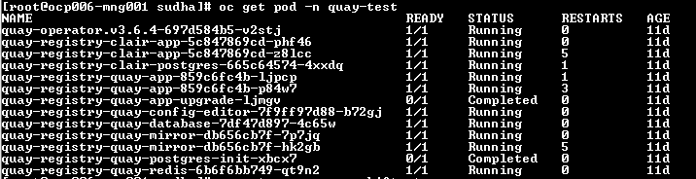

These are PVC and OBC which has been used by our quay application .

If we describe the PVC we can see these are used by quay pods a shown in below screenshot.
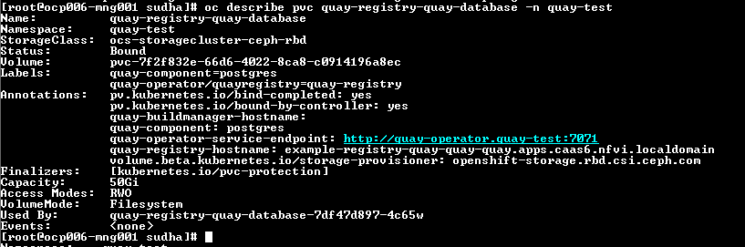

However, when we add the storage pool as mentioned in doc [1] section 8.3.2
We can see below 60GB storage pool as shown in below snap:
But when we describe this PVC we have not found these PVC has been used by our quay pods.
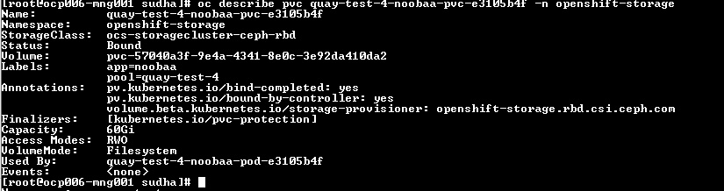
It’s showing it is getting used by noobaa pod which got created while performing above steps. These pods are not related to Quay.
Below are the screenshot of noobaa console for your reference:

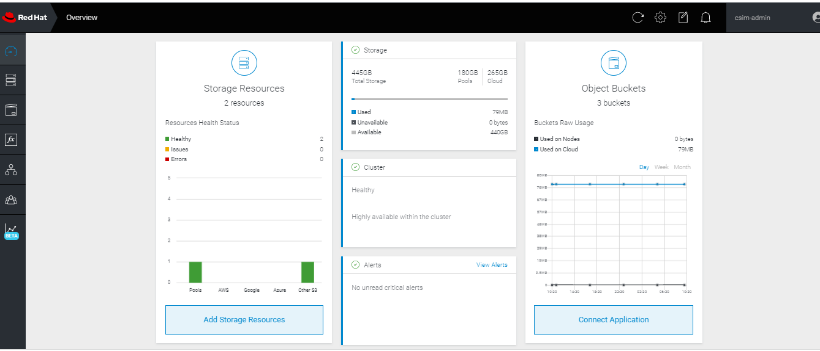
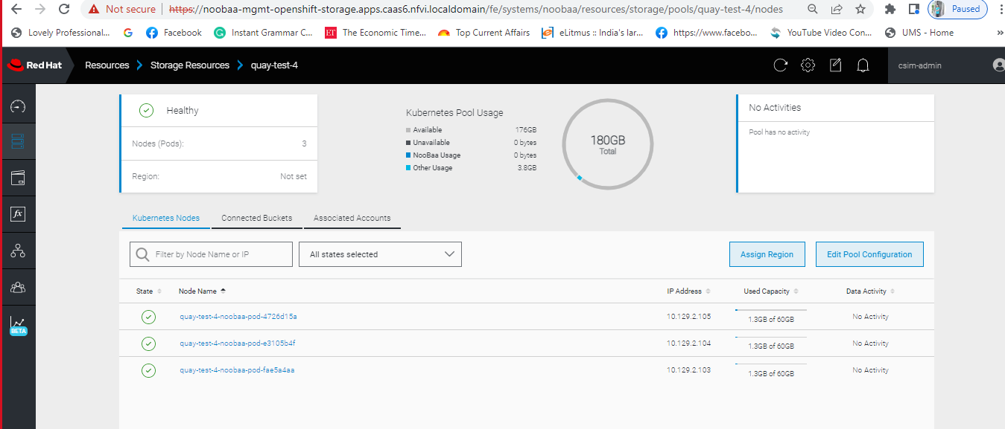

My question is: How we will make sure above PVC created through storage pool has been really used by our Quay applications and if not how can we configure these storage pool so that it can be configured for quay applications.

[1] https://access.redhat.com/documentation/en-us/red_hat_quay/3.6/html/deploy_red_hat_quay_on_openshift_with_the_quay_operator/advanced_concepts#operator-resize-storage

