$ oc get clusterversion
NAME VERSION AVAILABLE PROGRESSING SINCE STATUS
version 4.10.0-0.nightly-2022-02-15-041303 True False 169m Cluster version is 4.10.0-0.nightly-2022-02-15-041303

1. Install Loki to your clusterhelm repo update
helm repo add grafana https://grafana.github.io/helm-charts
helm repo update
helm upgrade --install loki grafana/loki

2. Deploy NOO
git clone https://github.com/netobserv/network-observability-operator
cd network-observability-operator
make deploy

3. Deploy flow collector
$ oc create -f /home/jechen/netobserv-test/flows_v1alpha1_flowcollector.yaml
flowcollector.flows.netobserv.io/cluster created

4.
$ oc patch console.operator.openshift.io cluster --type='json' -p '[{"op": "add", "path": "/spec/plugins", "value": ["network-observability-plugin"]}]'
console.operator.openshift.io/cluster patched

$ oc get all
NAME READY STATUS RESTARTS AGE
pod/loki-0 1/1 Running 0 2m4s

NAME TYPE CLUSTER-IP EXTERNAL-IP PORT(S) AGE
service/kubernetes ClusterIP 172.30.0.1 <none> 443/TCP 3h18m
service/loki ClusterIP 172.30.247.211 <none> 3100/TCP 2m5s
service/loki-headless ClusterIP None <none> 3100/TCP 2m5s
service/openshift ExternalName <none> kubernetes.default.svc.cluster.local <none> 3h12m

NAME READY AGE
statefulset.apps/loki 1/1 2m4s

$ oc get all -n network-observability
NAME READY STATUS RESTARTS AGE
pod/goflow-kube-bdc94fd94-gh9z6 1/1 Running 0 58s
pod/netobserv-controller-manager-566c4f8c5-997bn 2/2 Running 0 71s
pod/network-observability-plugin-d87749fb9-hcfdz 1/1 Running 0 58s

NAME TYPE CLUSTER-IP EXTERNAL-IP PORT(S) AGE
service/goflow-kube ClusterIP 172.30.176.58 <none> 2055/UDP 58s
service/netobserv-metrics-service ClusterIP 172.30.19.151 <none> 8443/TCP 72s
service/network-observability-plugin ClusterIP 172.30.142.153 <none> 9001/TCP 58s

NAME READY UP-TO-DATE AVAILABLE AGE
deployment.apps/goflow-kube 1/1 1 1 59s
deployment.apps/netobserv-controller-manager 1/1 1 1 72s
deployment.apps/network-observability-plugin 1/1 1 1 59s

NAME DESIRED CURRENT READY AGE
replicaset.apps/goflow-kube-bdc94fd94 1 1 1 59s
replicaset.apps/netobserv-controller-manager-566c4f8c5 1 1 1 72s
replicaset.apps/network-observability-plugin-d87749fb9 1 1 1 59s

$ oc -n network-observability logs goflow-kube-bdc94fd94-gh9z6
time="2022-02-15T18:53:39Z" level=info msg="Starting goflow-kube 1.16.7 at log level info" module=goflow-kube
time="2022-02-15T18:53:39Z" level=info msg="Using command line supplied config" configFile=/etc/goflow-kube/config.yaml module=goflow-kube
time="2022-02-15T18:53:39Z" level=info msg="Creating health HTTP endpoint..." module=goflow-kube
time="2022-02-15T18:53:39Z" level=info msg="Creating loki exporter..." module=goflow-kube
time="2022-02-15T18:53:39Z" level=info msg="Start listening on netflow://:2055" module=goflow-kube
time="2022-02-15T18:53:39Z" level=info msg="Using in-cluster kube config" module=goflow-kube
time="2022-02-15T18:53:39Z" level=info msg="waiting for informers to be synchronized" module=goflow-kube
time="2022-02-15T18:53:39Z" level=info msg="Starting reader..." module=goflow-kube
time="2022-02-15T18:54:40Z" level=warning msg="Failed to get Service [ip=10.0.0.7]" module=goflow-kube
time="2022-02-15T18:54:40Z" level=warning msg="Failed to get Service [ip=10.129.0.2]" module=goflow-kube
time="2022-02-15T18:54:40Z" level=warning msg="Failed to get Service [ip=10.129.0.2]" module=goflow-kube
time="2022-02-15T18:54:41Z" level=warning msg="Failed to get Service [ip=10.0.0.7]" module=goflow-kube
time="2022-02-15T18:54:41Z" level=warning msg="Failed to get Service [ip=10.130.0.2]" module=goflow-kube
time="2022-02-15T18:54:43Z" level=warning msg="Failed to get Service [ip=10.0.0.7]" module=goflow-kube
time="2022-02-15T18:54:43Z" level=warning msg="Failed to get Service [ip=10.0.0.7]" module=goflow-kube
time="2022-02-15T18:54:43Z" level=warning msg="Failed to get Service [ip=10.129.0.2]" module=goflow-kube
time="2022-02-15T18:54:43Z" level=warning msg="Failed to get Service [ip=10.129.0.2]" module=goflow-kube
time="2022-02-15T18:54:43Z" level=warning msg="Failed to get Service [ip=10.129.0.2]" module=goflow-kube
time="2022-02-15T18:54:43Z" level=warning msg="Failed to get Service [ip=10.129.0.2]" module=goflow-kube
time="2022-02-15T18:54:43Z" level=warning msg="Failed to get Service [ip=10.129.0.2]" module=goflow-kube
time="2022-02-15T18:54:43Z" level=warning msg="Failed to get Service [ip=10.129.0.2]" module=goflow-kube
time="2022-02-15T18:54:43Z" level=warning msg="Failed to get Service [ip=10.128.0.2]" module=goflow-kube
time="2022-02-15T18:54:43Z" level=warning msg="Failed to get Service [ip=10.128.0.2]" module=goflow-kube
time="2022-02-15T18:54:43Z" level=warning msg="Failed to get Service [ip=10.129.0.2]" module=goflow-kube

$ oc get route --all-namespaces
NAMESPACE NAME HOST/PORT PATH SERVICES PORT TERMINATION WILDCARD
openshift-authentication oauth-openshift oauth-openshift.apps.jechen-0215a.qe.gcp.devcluster.openshift.com oauth-openshift 6443 passthrough/Redirect None
openshift-console console console-openshift-console.apps.jechen-0215a.qe.gcp.devcluster.openshift.com console https reencrypt/Redirect None
openshift-console downloads downloads-openshift-console.apps.jechen-0215a.qe.gcp.devcluster.openshift.com downloads http edge/Redirect None
openshift-ingress-canary canary canary-openshift-ingress-canary.apps.jechen-0215a.qe.gcp.devcluster.openshift.com ingress-canary 8080 edge/Redirect None
openshift-monitoring alertmanager-main alertmanager-main-openshift-monitoring.apps.jechen-0215a.qe.gcp.devcluster.openshift.com /api alertmanager-main web reencrypt/Redirect None
openshift-monitoring grafana grafana-openshift-monitoring.apps.jechen-0215a.qe.gcp.devcluster.openshift.com grafana https reencrypt/Redirect None
openshift-monitoring prometheus-k8s prometheus-k8s-openshift-monitoring.apps.jechen-0215a.qe.gcp.devcluster.openshift.com prometheus-k8s web reencrypt/Redirect None
openshift-monitoring thanos-querier thanos-querier-openshift-monitoring.apps.jechen-0215a.qe.gcp.devcluster.openshift.com /api thanos-querier web reencrypt/Redirect None

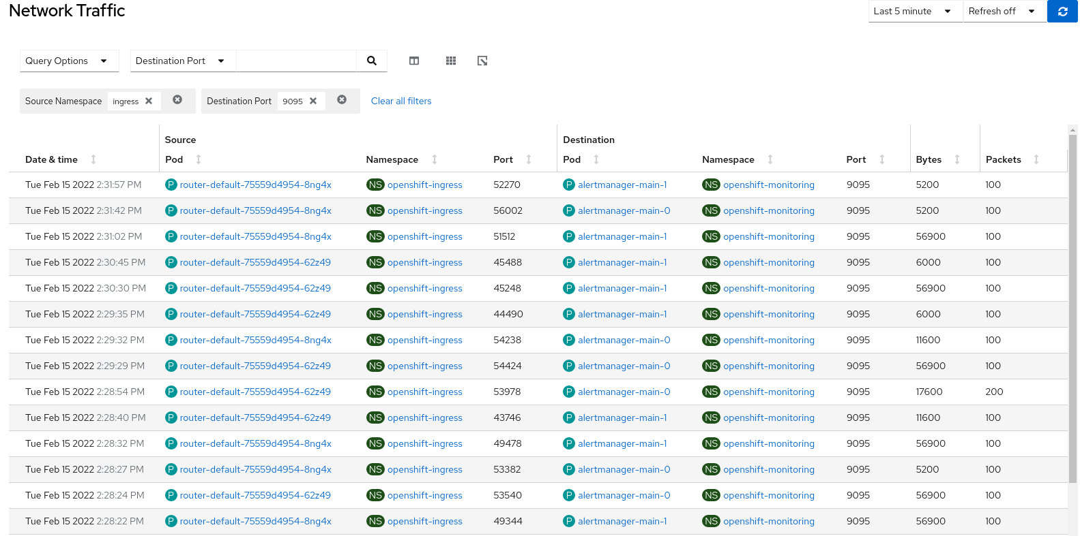

==> Column Matching-all query succeeded

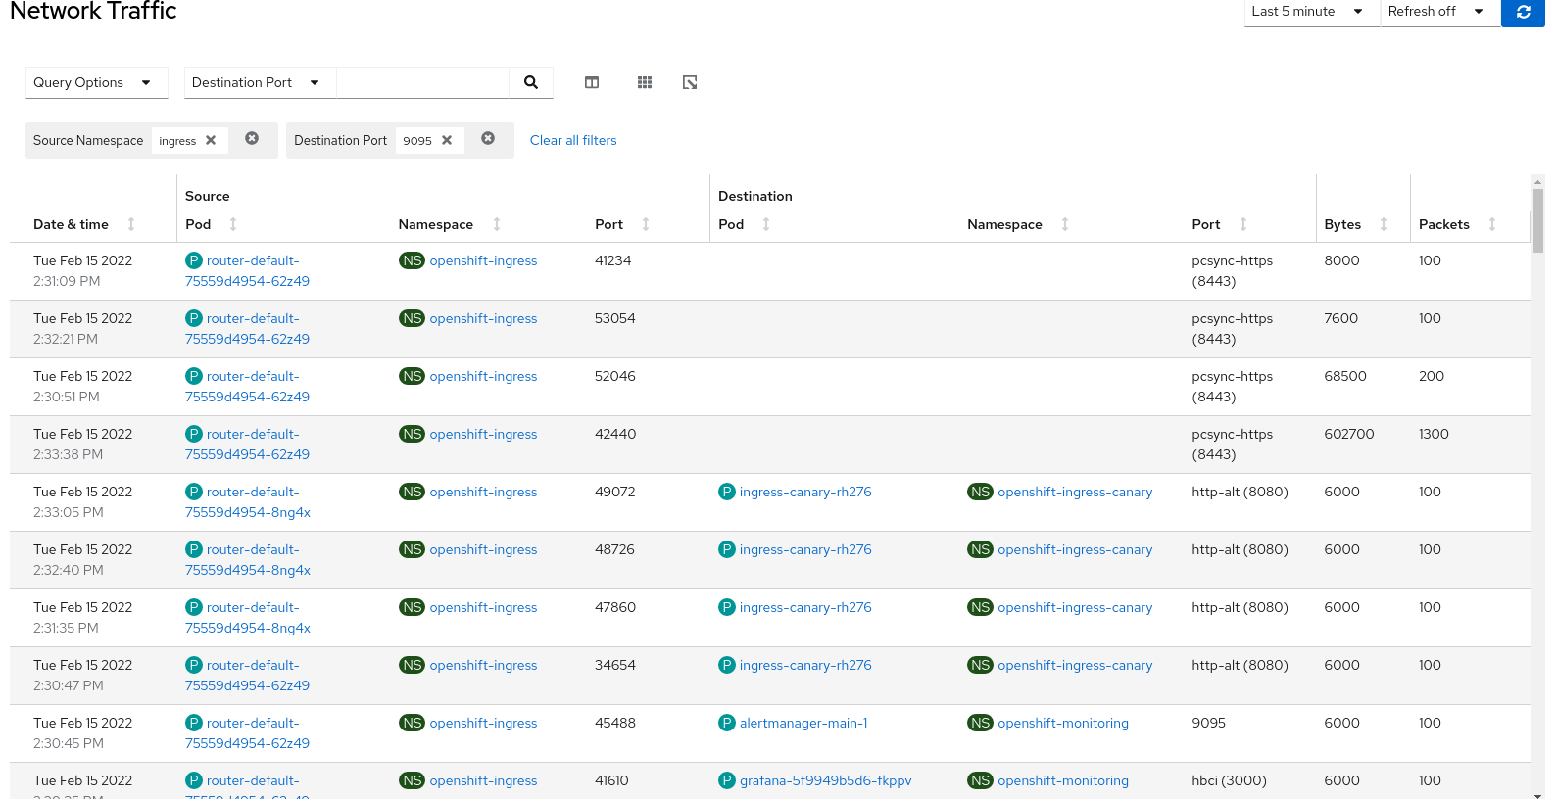

===> Column Matching-any query succeeded

