Overview
The performance test is executed on KIE Server so it actually measures performance of the jBPM as a running service instead of focusing on raw execution of the APIs. So anyone can perform this tests by following the instructions at the end of this article.

Environment
The test has been executed on:
- community 7.55.0 single zip distribution that you can download on jbpm.org
  - WildFly 11
- hardware
  - Windows 10
  - Processor Intel Core 11th Gen Intel(R) Core(TM) i5-1135G7 @ 2.40GHz 2.42 GHz
  - Memory 16GB
- JMeter as the test client
Components (client, application server and database) are on the same hardware, meaning they share the resources.

Performance test
Tests are separated per scenario and then number of concurrent threads. The test is designed to run fixed number of process instances (1000) in the shortest possible time.

Script task
Most basic process definition that runs directly from the beginning till the end without persisting any state in between. Task is of sync type and we are using per process instance deployment strategy
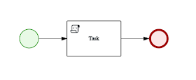

Script task execution results:

PostgreSQL
On same machine, as JBPM server is

Throughput:
- 1 thread – 59.6instances/s
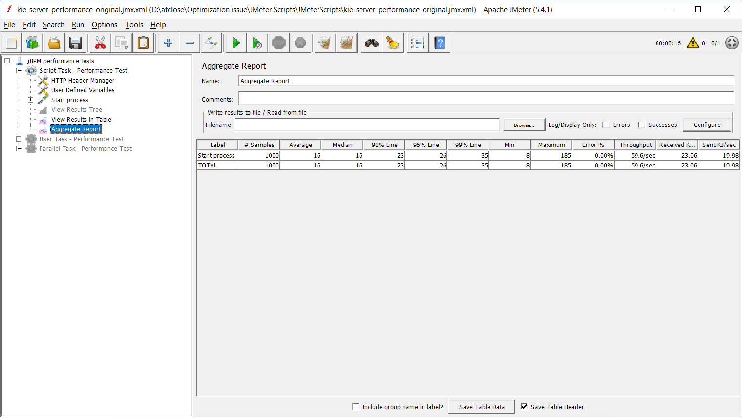
- 4 threads – 125.4instances/s
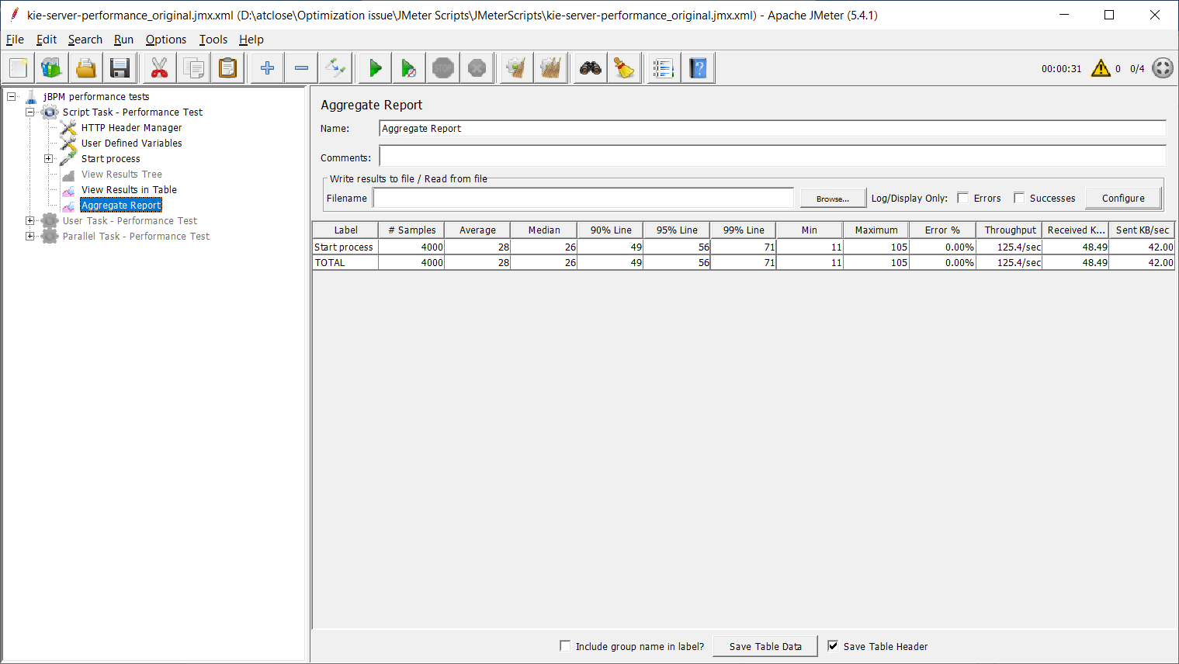
- 8 threads – 123.4 instances/s
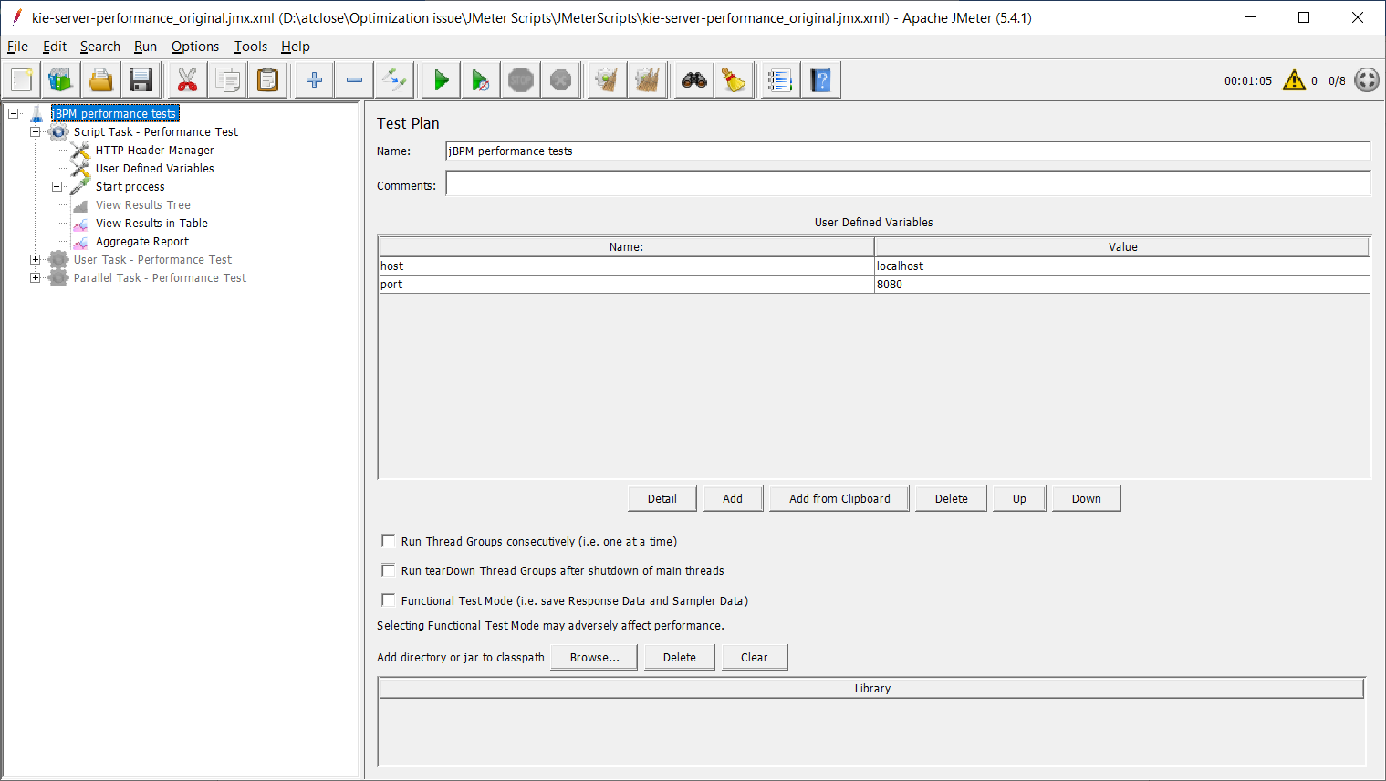

H2
On same machine, as JBPM server is

Throughput:
- 1 thread - 86.0 instances/s
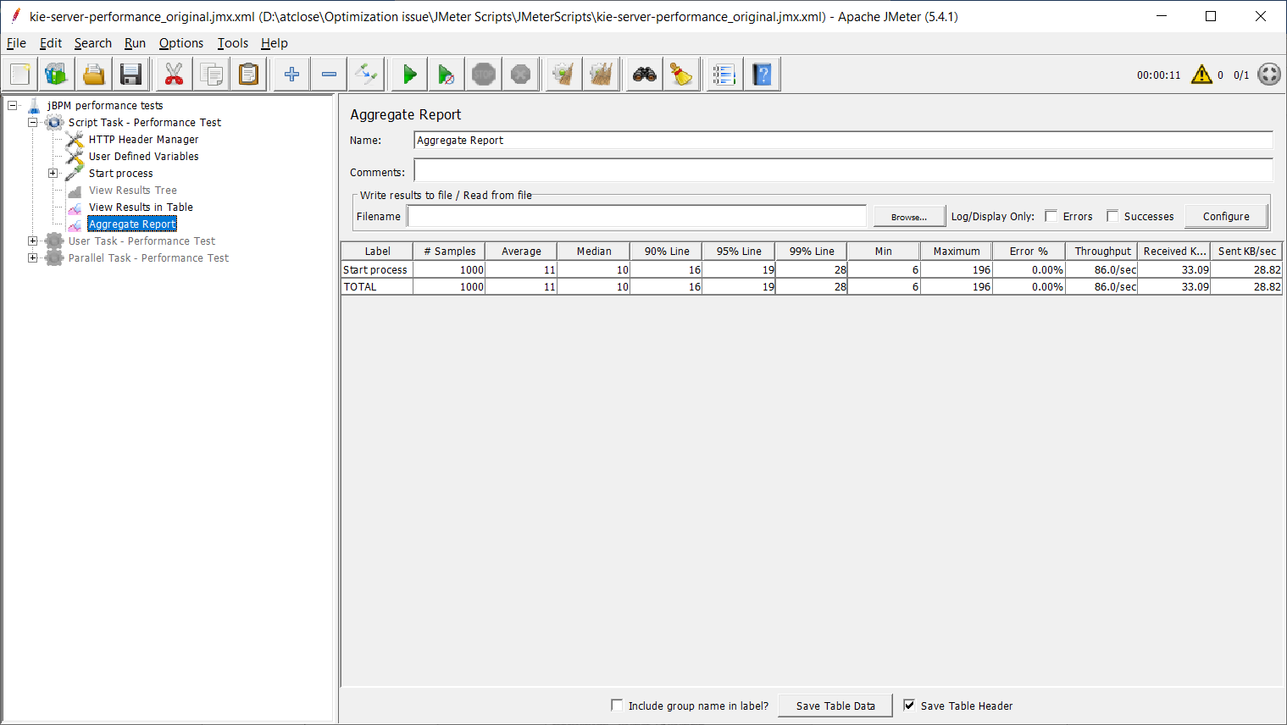
- 4 threads – 199.4 instances/s
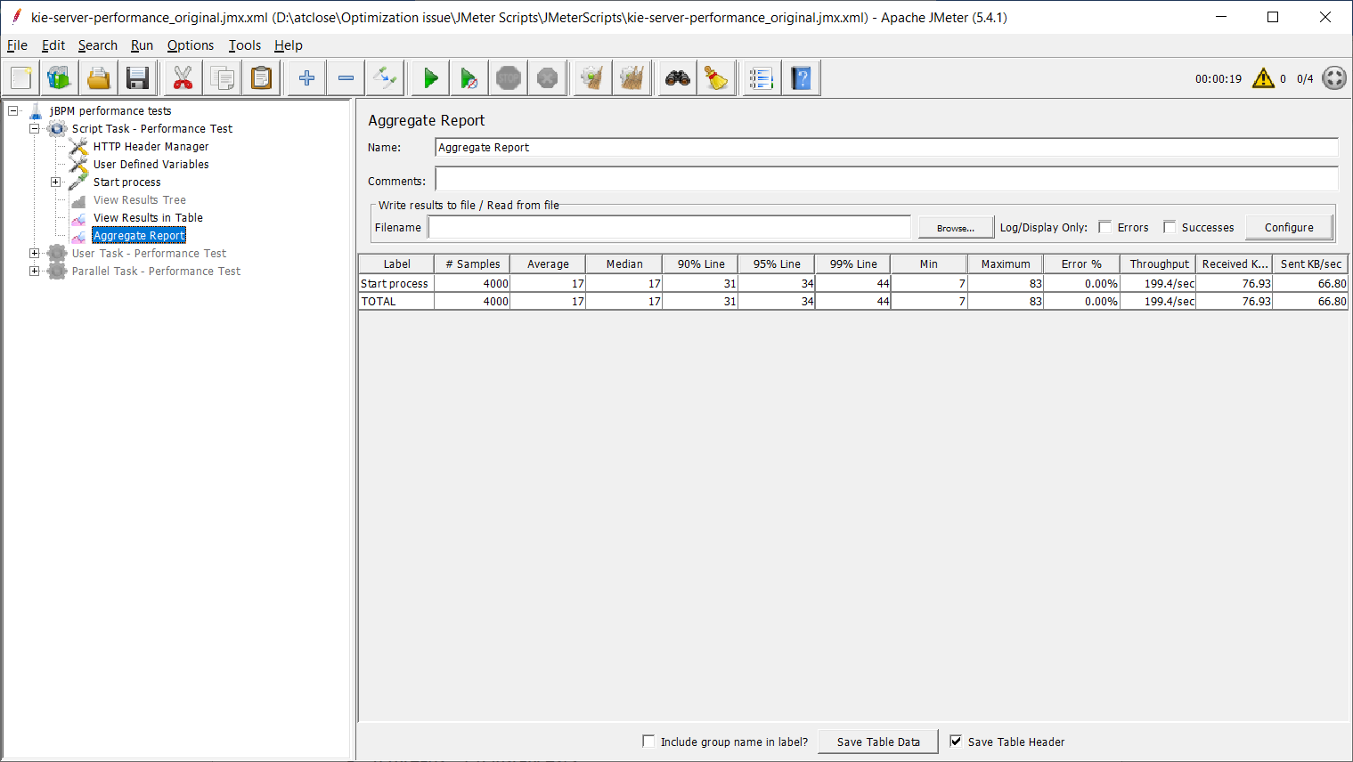
- 8 threads – 216.5 instances/s

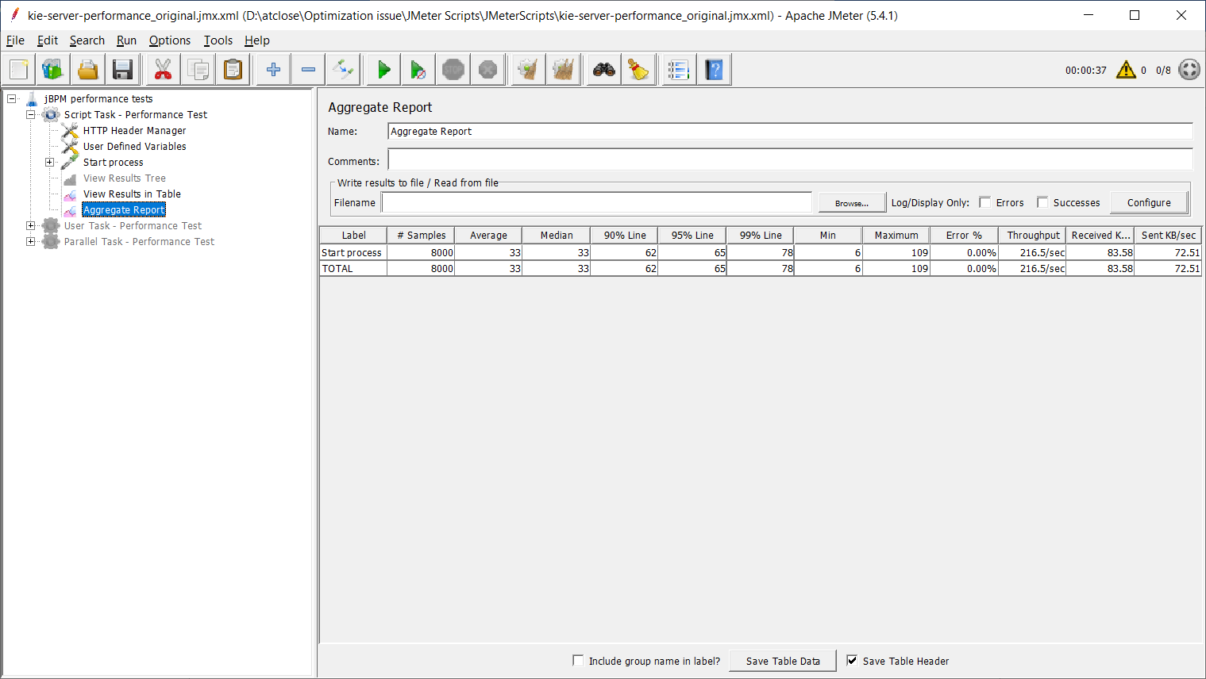

MS SQL Server 12

Throughput:
- 1 thread – 16.2 instances/s
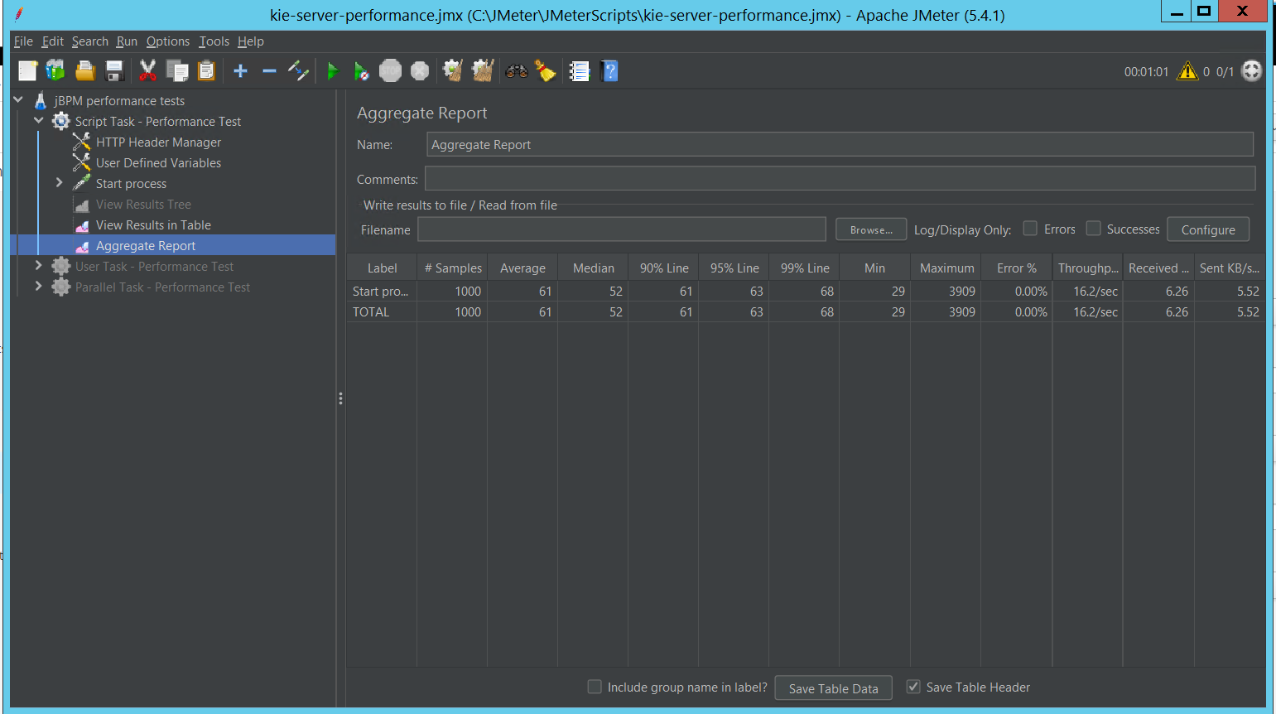
- 4 threads – 18.8 instances/s
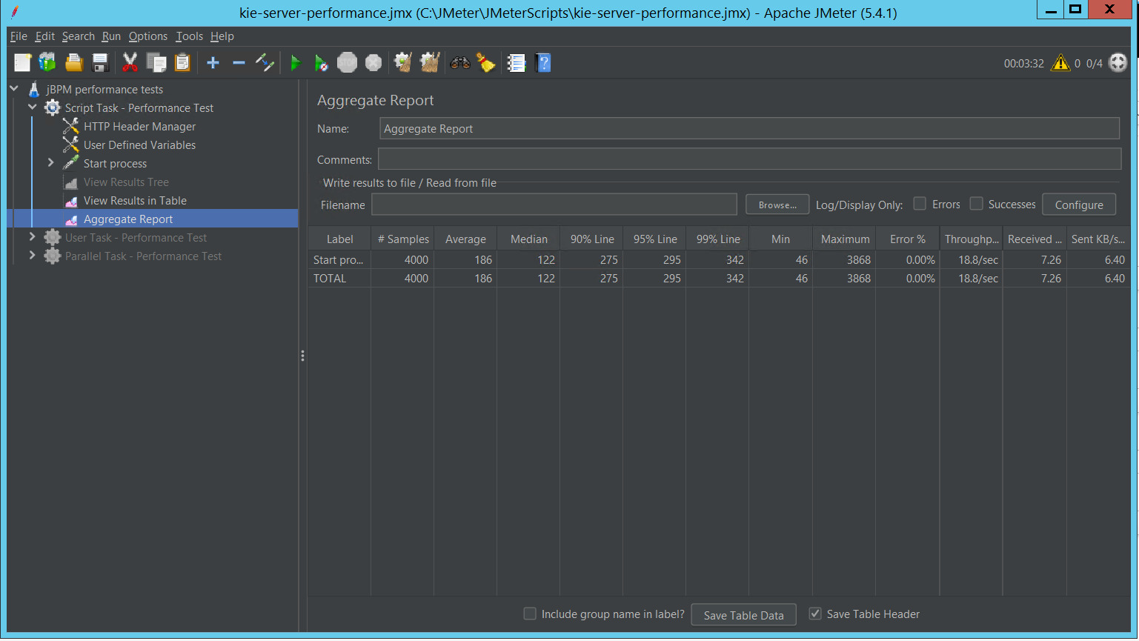
- 8 threads – 18.6 instances/s

