ADD PROJECT -> TestForm

Create new Data Object -> Person -> add field:
name (String)
surname (string)

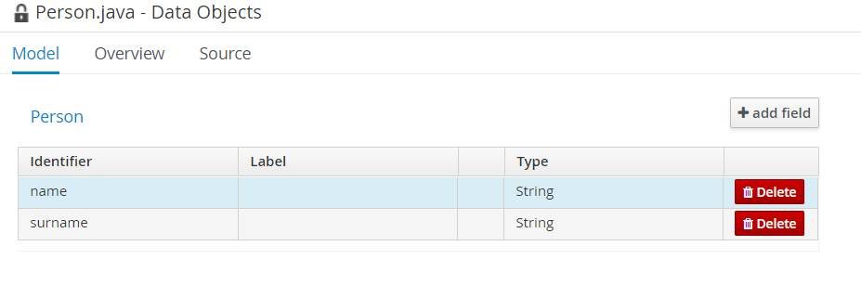
SAVE

Add Business Process - FormProcess

Add Start, User Task, End
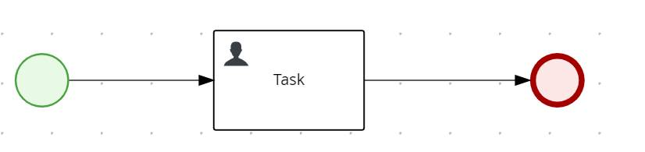

Add process cariable “person” of type Person.
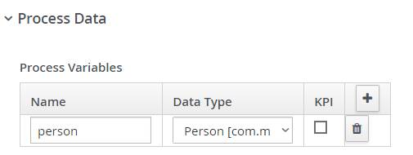

in User Task, add kie-server as Groups. In userTask output add person of type Person, targeting the process variable person

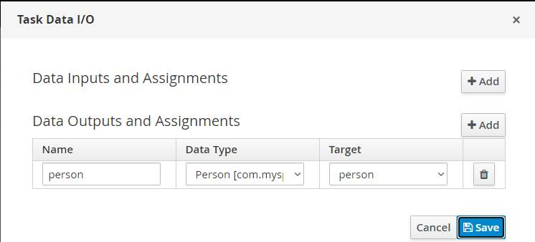

in On Exit Action insert:
System.out.println("name: "+person.getName());
System.out.println("surname: "+person.getSurname());

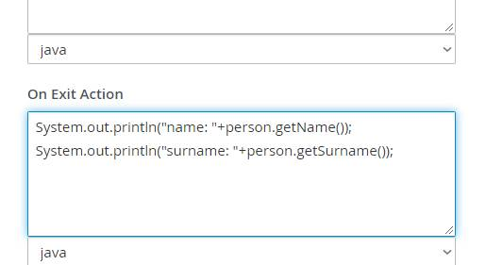

Create all forms.

DEPLOY

Execute the process.
From log:
2020-09-29 10:29:51,023 INFO [stdout] (default task-25) name: John

2020-09-29 10:29:51,023 INFO [stdout] (default task-25) surname: Smith

Go back to project, add the “email” field to Person data model.

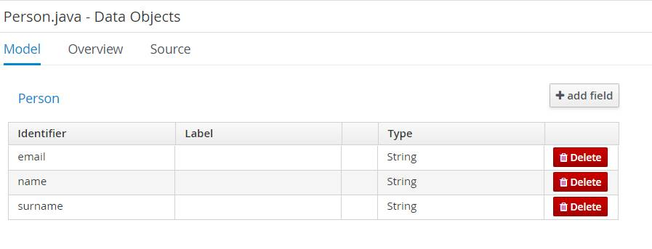
Cancel all forms.
In User task add the line: System.out.println("email: "+person.getEmail());
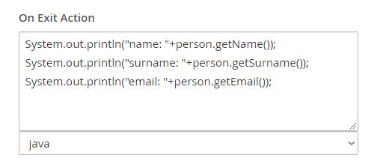
Create all forms.
Deploy.
Execute the process again, Fill the form fields (that seems to be updated):
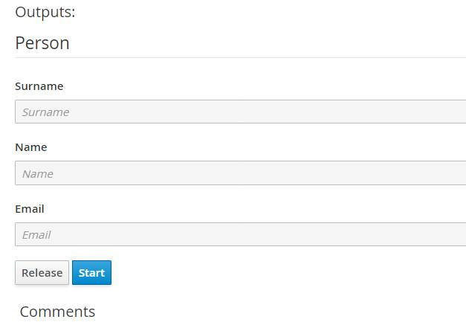

But in the log you can see the null on Email filed:

2020-09-29 10:34:07,081 INFO [stdout] (default task-24) name: Paolino

2020-09-29 10:34:07,081 INFO [stdout] (default task-24) surname: Paperino

2020-09-29 10:34:07,081 INFO [stdout] (default task-24) email: null

