Single Sign on configuration of application deployed on Instance 2 Wildfly server
Part -1

Environment
Wildfly-11-final :
Host : nl005164-Experimental server
Created 3 instances:Instance 1 , Instance 2, Instance3
Deployment : Depl0yed Samlpe.war file on Instance-2
Keycloak 4.0.0.0 Final
Keycloak SAML adpaters: Installed keycloak saml adpaters on wildfly server
OKTA : External Identity Provider
SAML 2.0 Standards
Master releam of keycloak

Keycloak Admin url : http://nl005164.tst.kohls.com:19017/auth
Step 1 :Click on Admin console

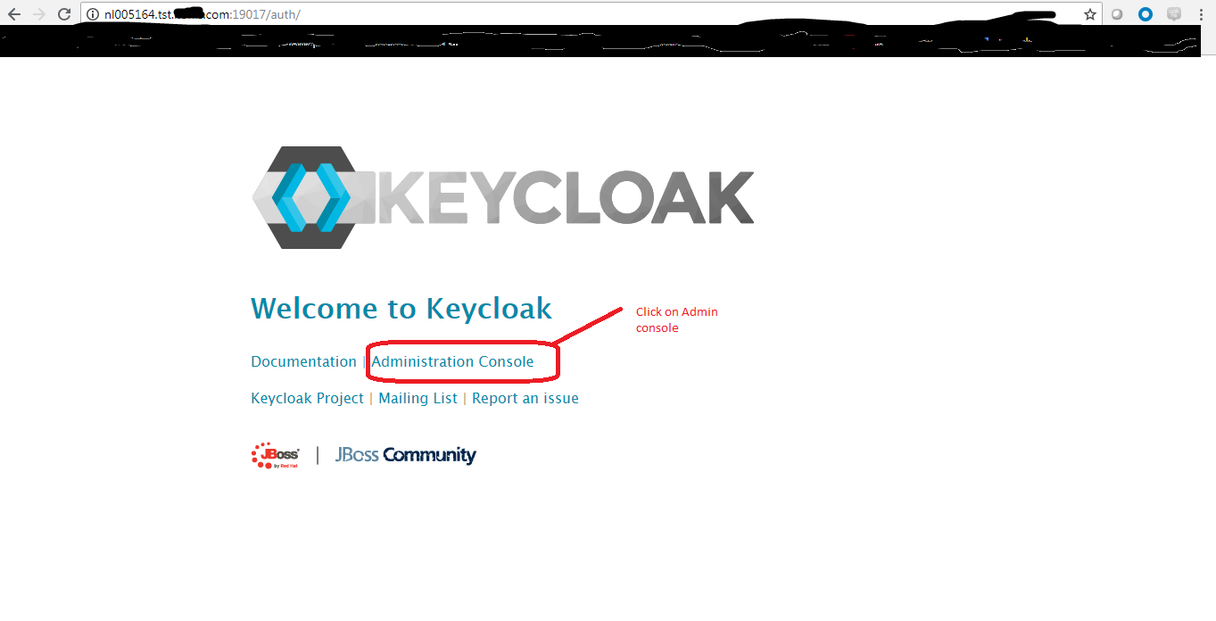

Step 2 : User name & Password

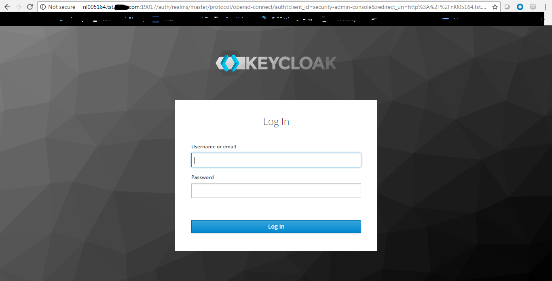

Step 3 : Configurations as a “Master Releam”
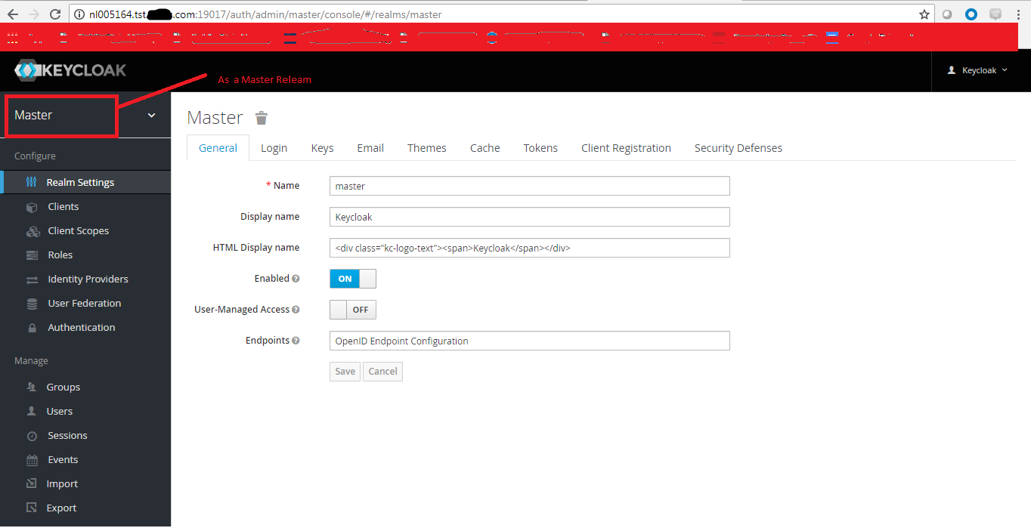
Step 4 : Creating a new “Client”
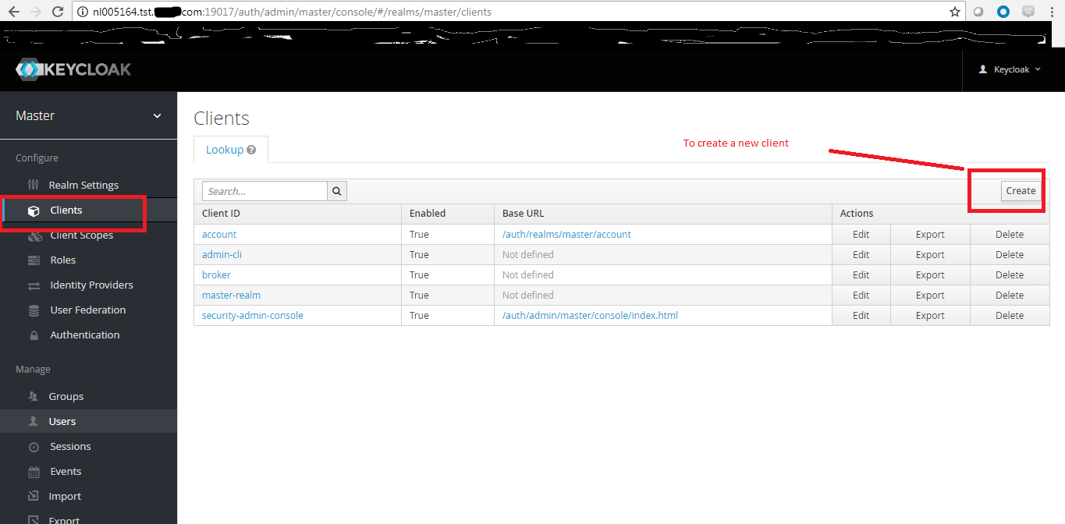

Step 5:
A )Gave Client –ID as “Sample-app”
B)Choosen Client protocol as SAML
C) Saved the attributes
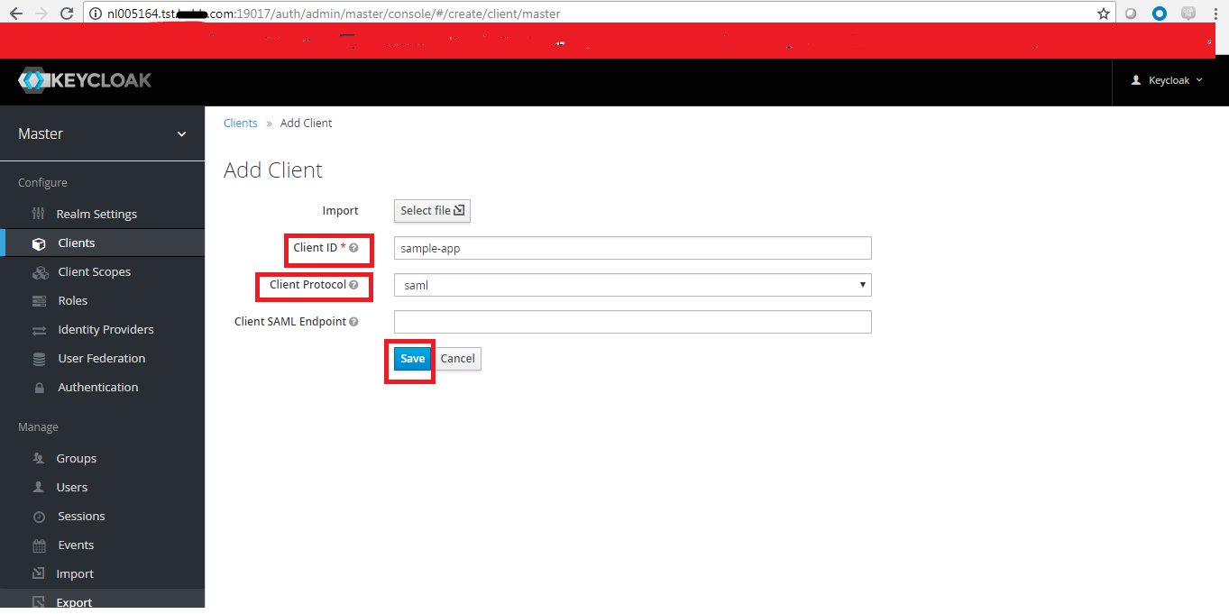
Step 6 :
a)After saving the page will re-direct to new client page like below
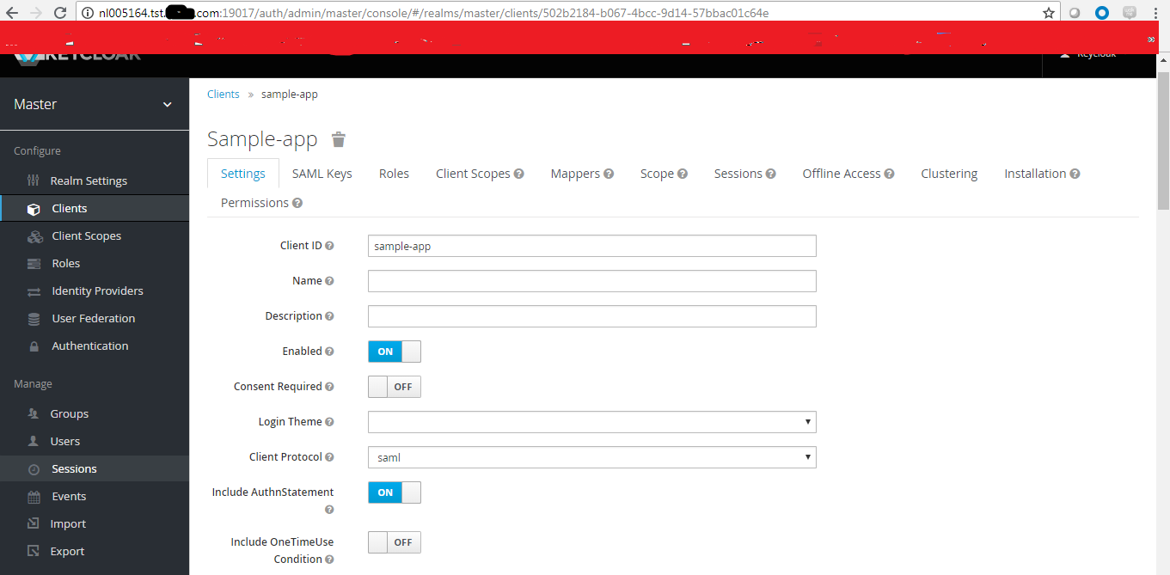
b)Choosen Name ID format as “Persistent” under client sample-app ‘s Settings tab .
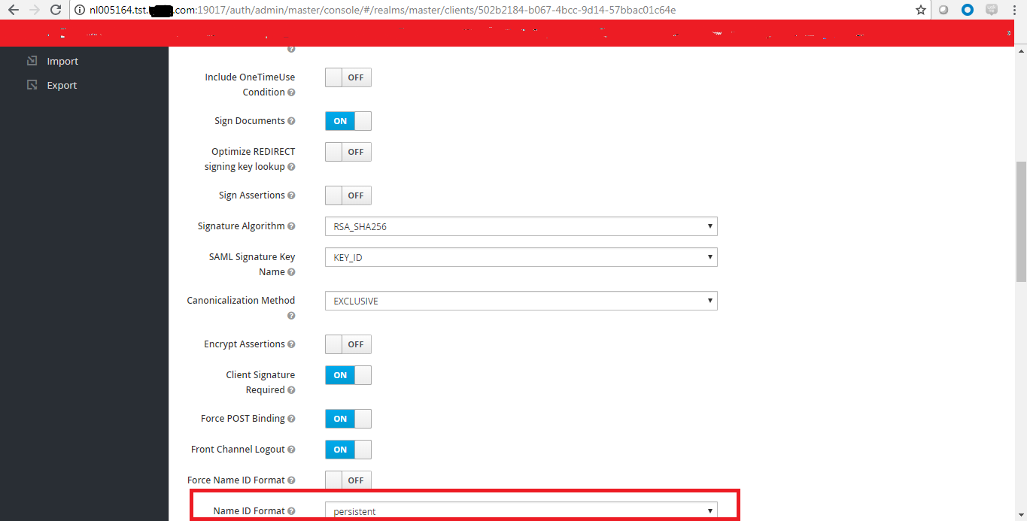

c)Gave “base url” as Application url http://nl005164.tst.kohls.com:19015/sample/ under client sample-app ‘s Settings tab .
(Sample app deployed on Instance 2 of Wildfly server –nl005164)
d)Saved the entire configuration for the client sample-app
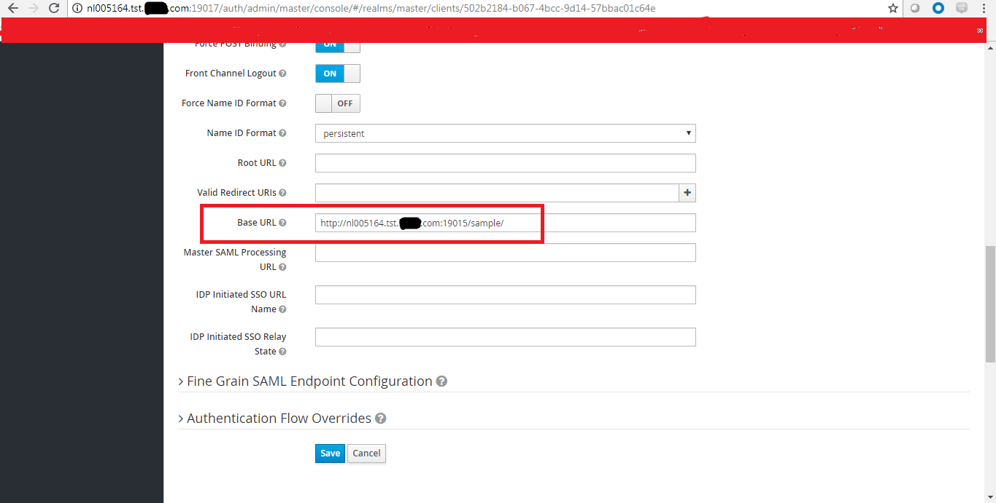

Step7 : Created “Role”

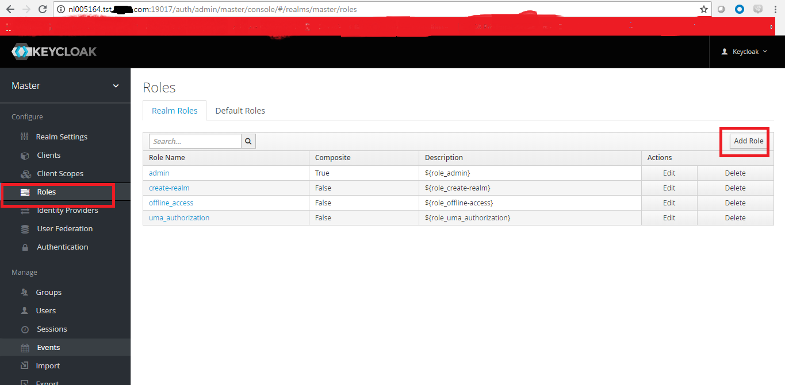
7.1)Gave role name as “wildfly-admin”
7.2)Saved
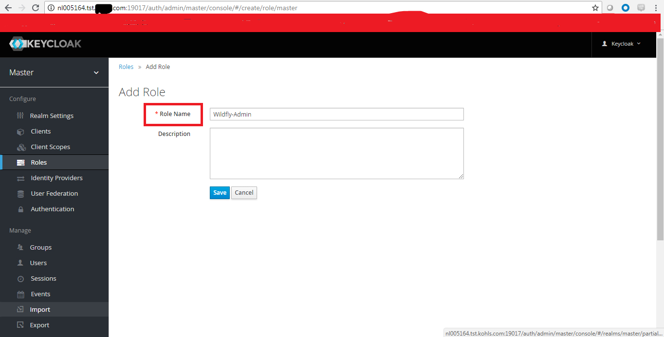

7.3) After saving newly created role redirected to below page where we can set up the composite roles , permissions ,users in roles
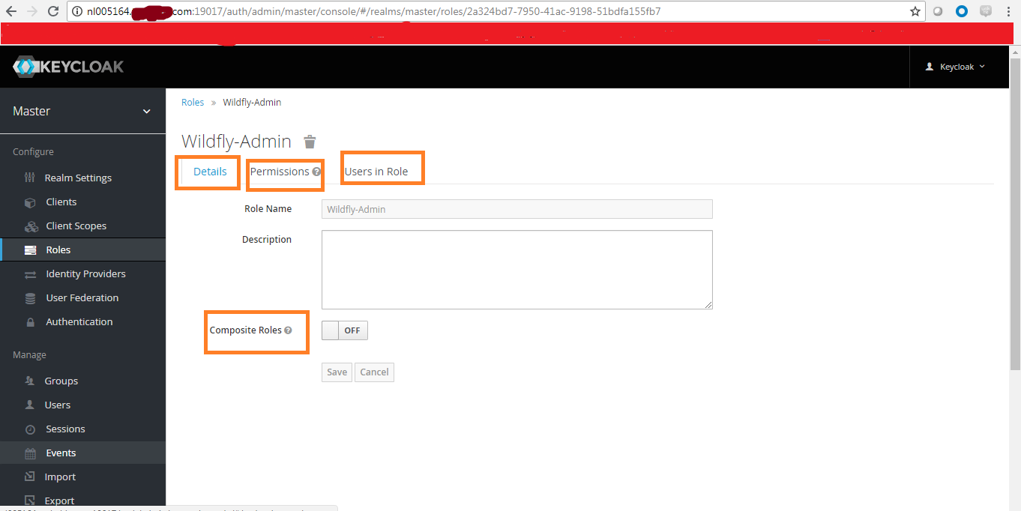

  - Enabled the composite roles and it showed “Releam Roles” and “Client Roles “for the role which we created
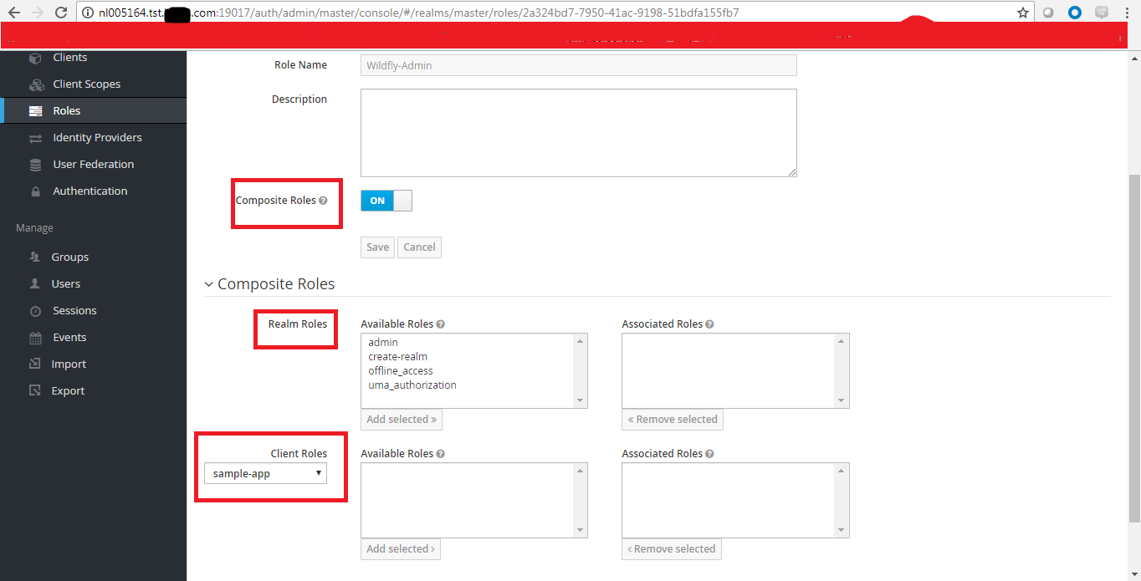
7.5)Enabled the permissions but did not “edit “ under actions tab .
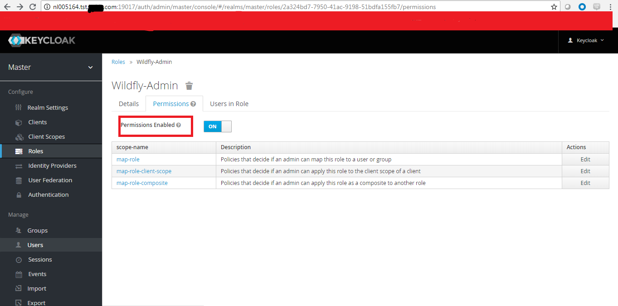

Step 8 : Adding up the “ Indentity Provider” .
8.1)Choosen the Saml v 2.0 protocol

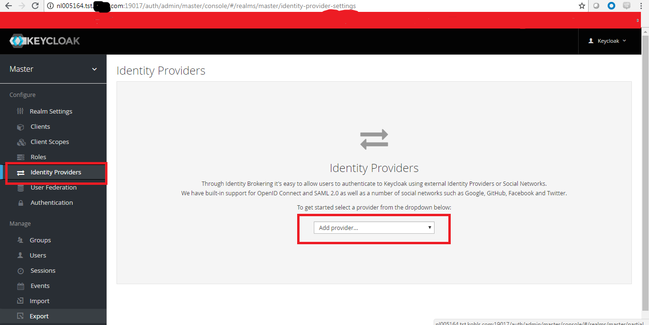

8.2)After selecting the Saml v 2.0 protocol it redirects to our new Identity provider page Where the “redirect url “ is the default and we can change the “alias name “

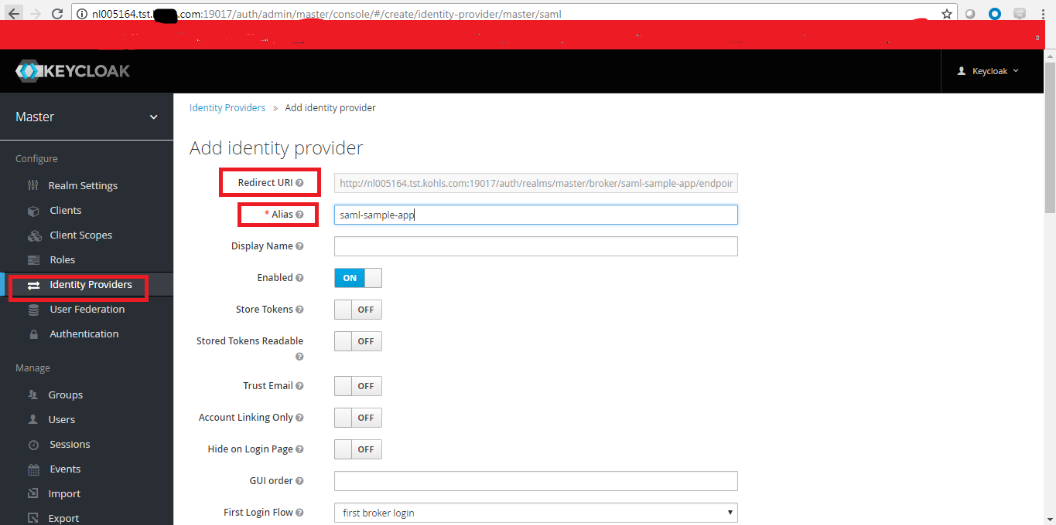
Redirect url
http://nl005164.tst.kohls.com:19017/auth/realms/master/broker/saml-sample-app/endpoint
Note :This redirect url is to be configured in okta (Check step 9.5)

Step 9 : Login to free trial okta
Username :
Password :
https://kohls-us.okta.com/
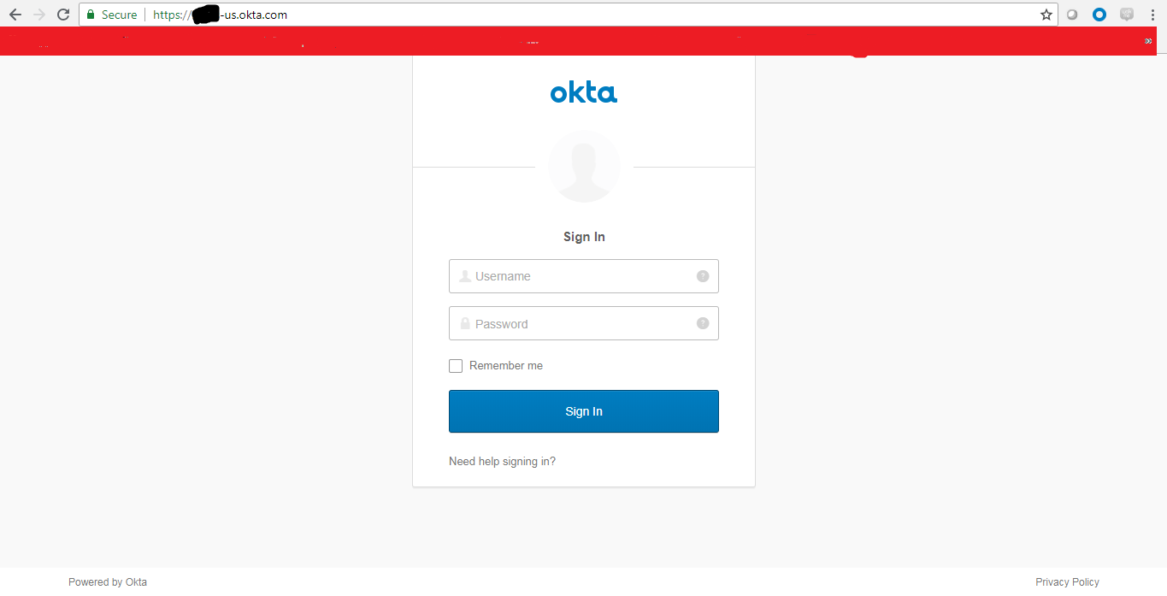
9.1)Click on Admin to manage the applications
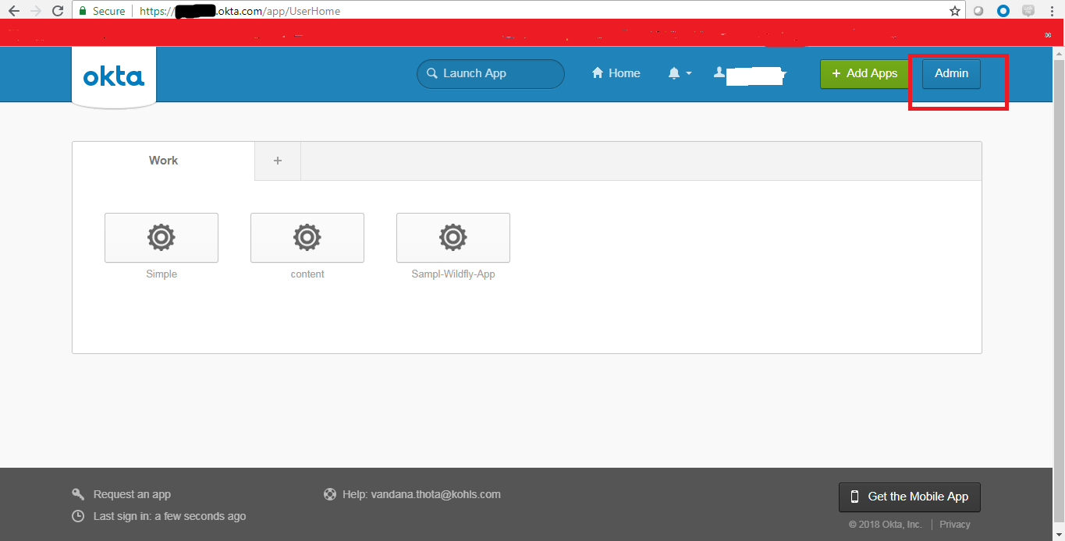
9.2) Click on Add applications
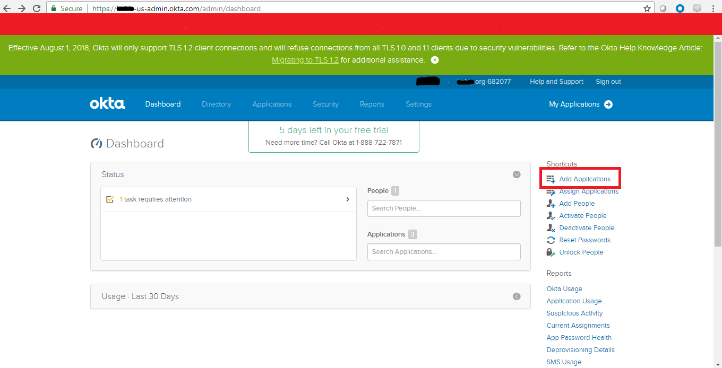
9.3)”Create New app”
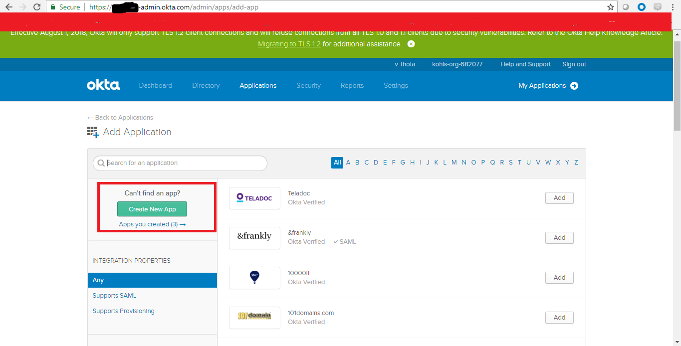
9.4)Select web and SAML2.0
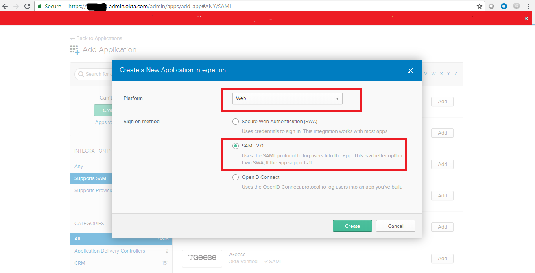
9.5)Provide app name “Sample-fly-app”

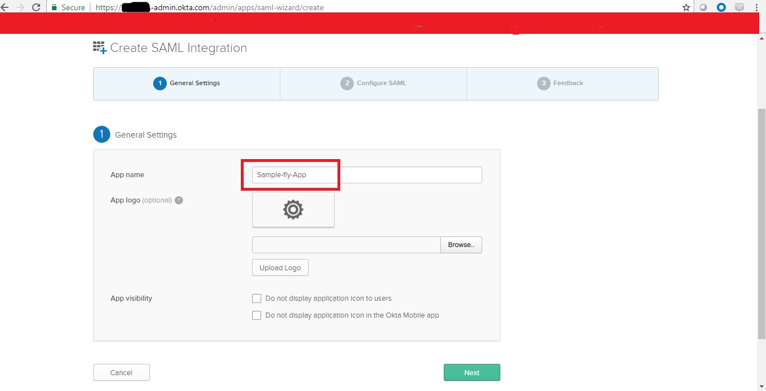

9.6)Providing the Redirect url from keycloak in okta as single sign on url and as Audience URL ( SP Entity ID)
http://nl005164.tst.kohls.com:19017/auth/realms/master/broker/saml-sample-app/endpoint
Note : Refer step (8.2)

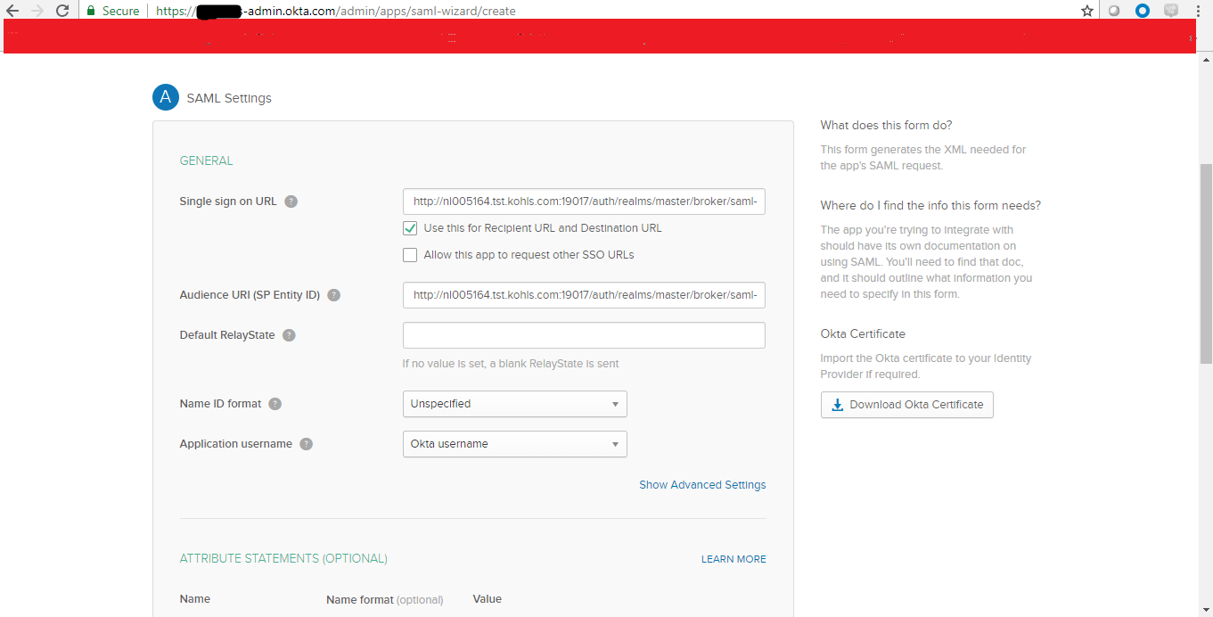

9.7)Provided random name and value
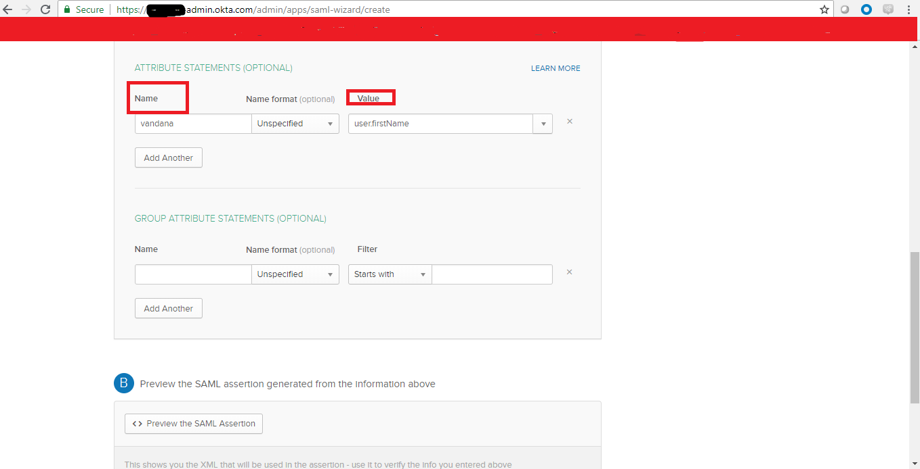
9.8)Click on next
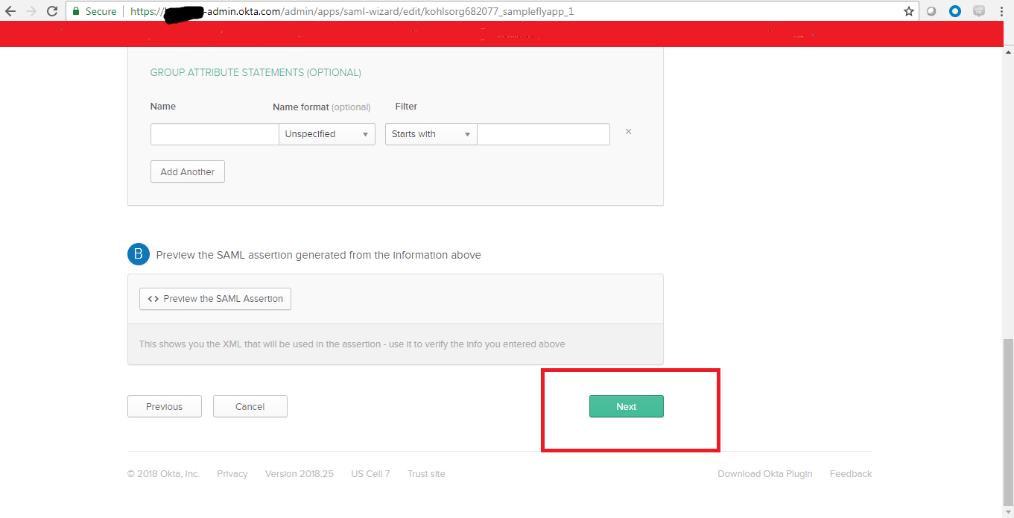
9.9)
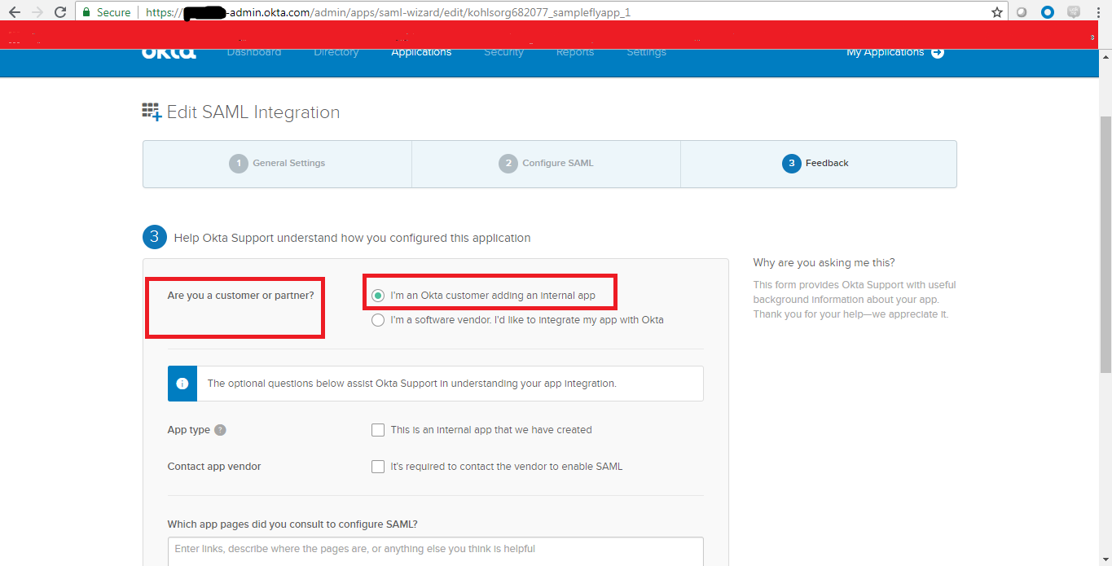

9.10)Scroll down and click next and click on finish on next page

9.11)Click on Identity Provider Metadata and this files. This IDP metadata file needs to be imported in keycloak under “Indentity provider tab “
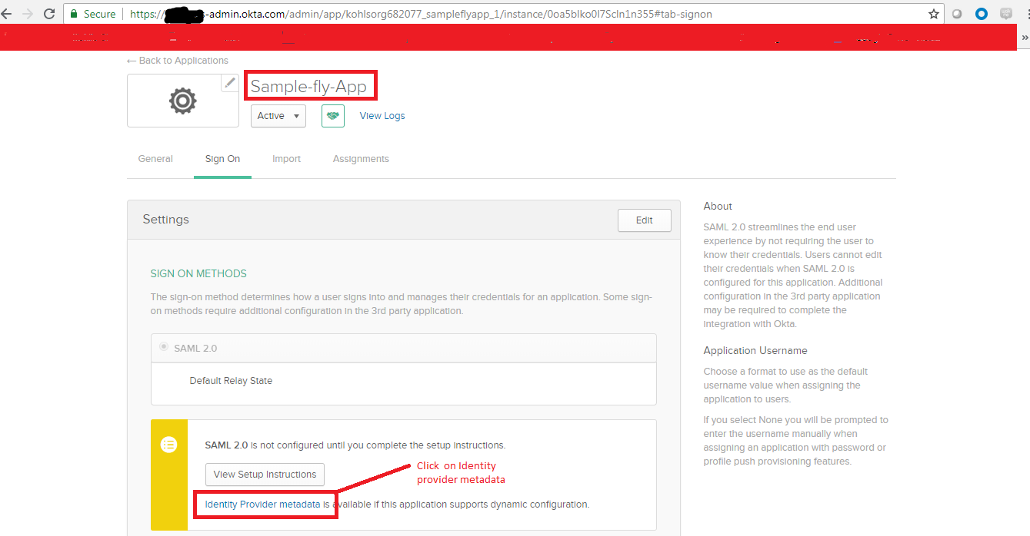
9.12)Click on save
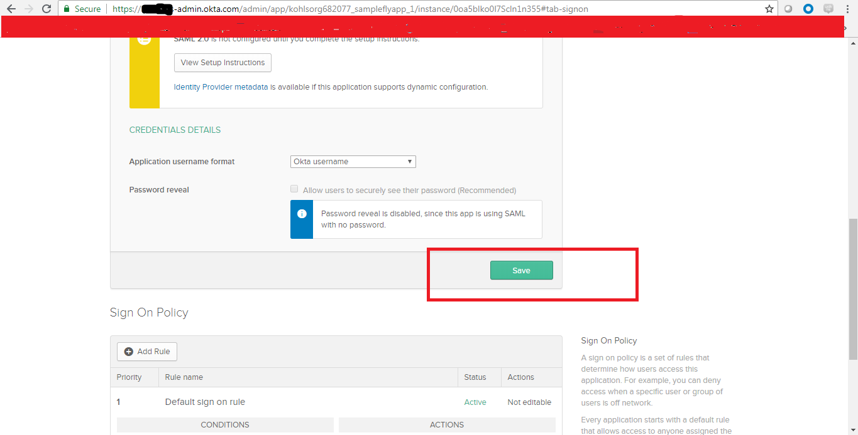
After saving this configuration . We can have the IDP metadata file from Okta (9.11)
and if we click it , that file redirects to new tab in the browser as below .
Save this file as with some random name “metadata.xml”
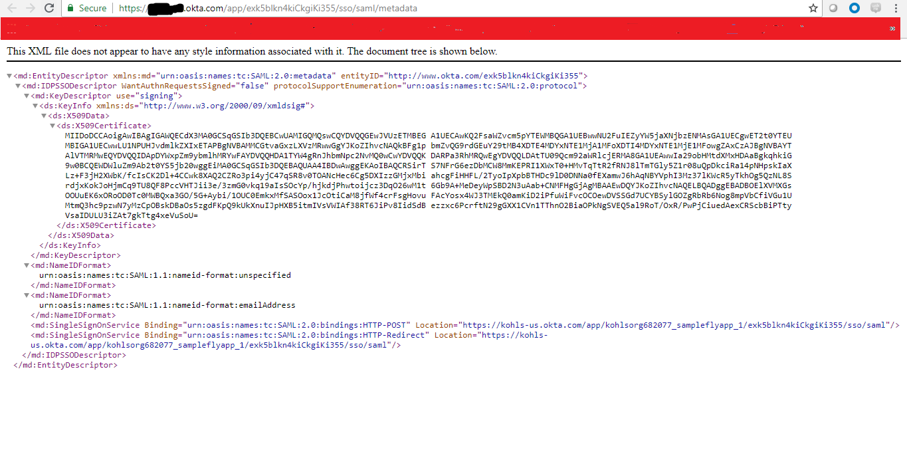
9.14)Assign the application in okat to a particular user . so that user can access to that newly added application when that user login to okta with the respective credentials.
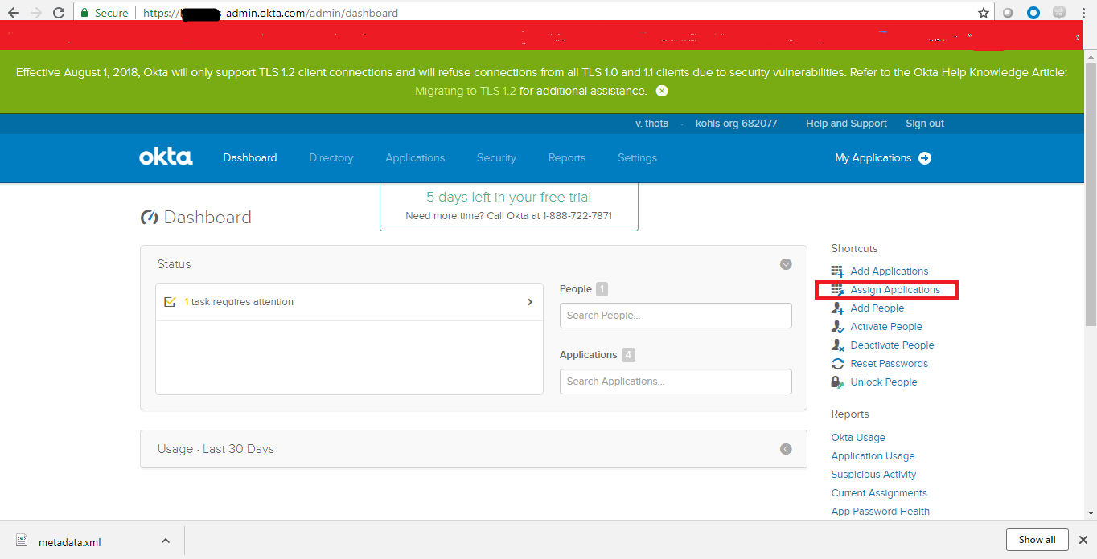
9.m Check the options of the application and users and click next

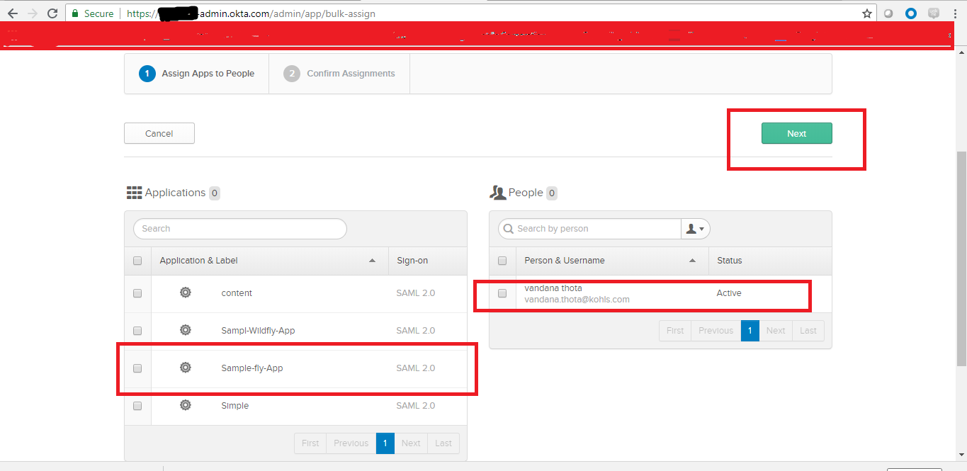

9. Click on confirm assignments
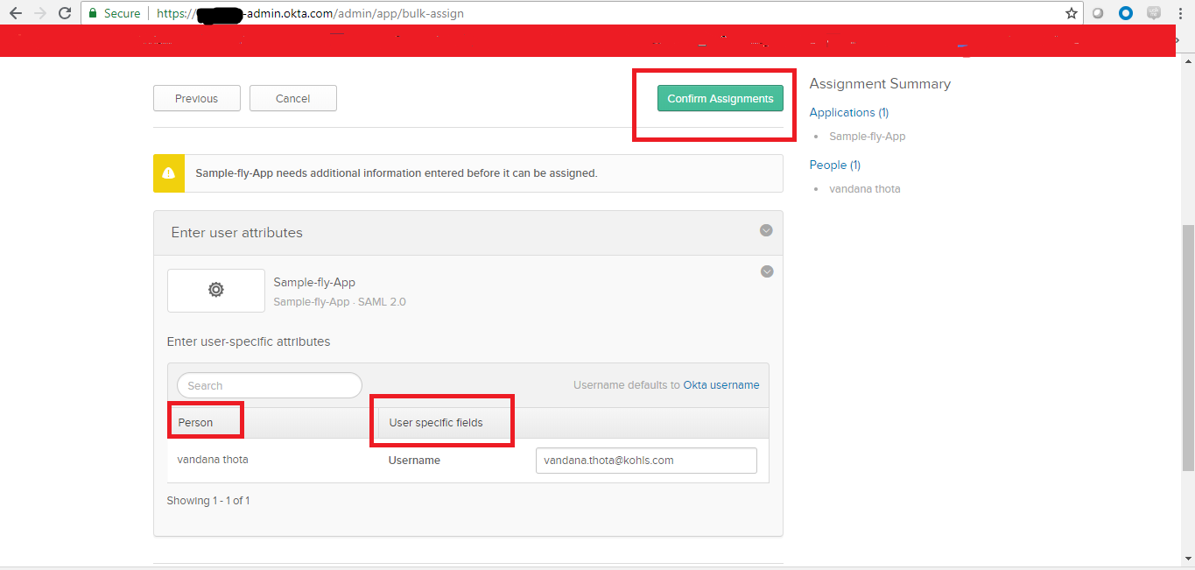

10) Importing Metadata file in keycloak :
10.1) Keycloak—>Identity Provider Select file Import Metadata file Save Result is shown as success in green color and on same Same page SSO url can be seen as one more result
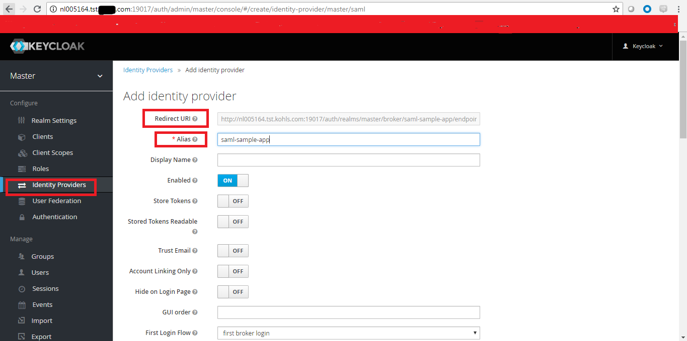
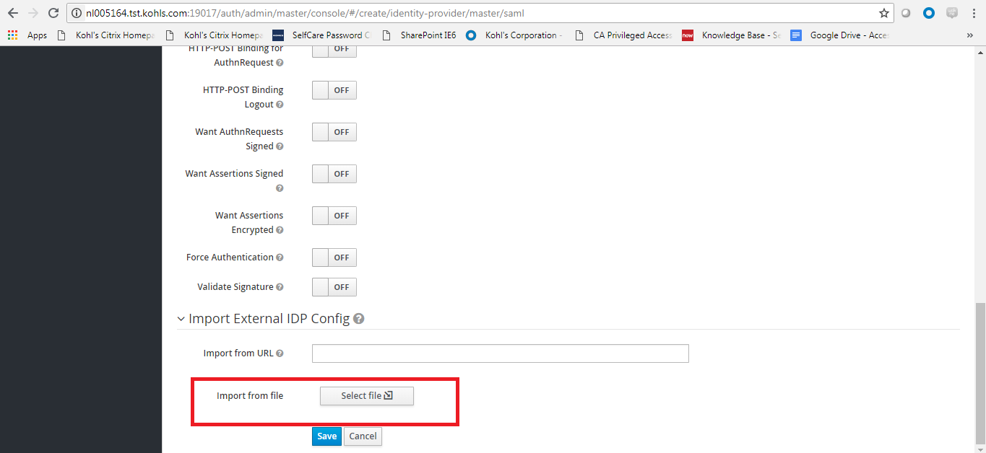
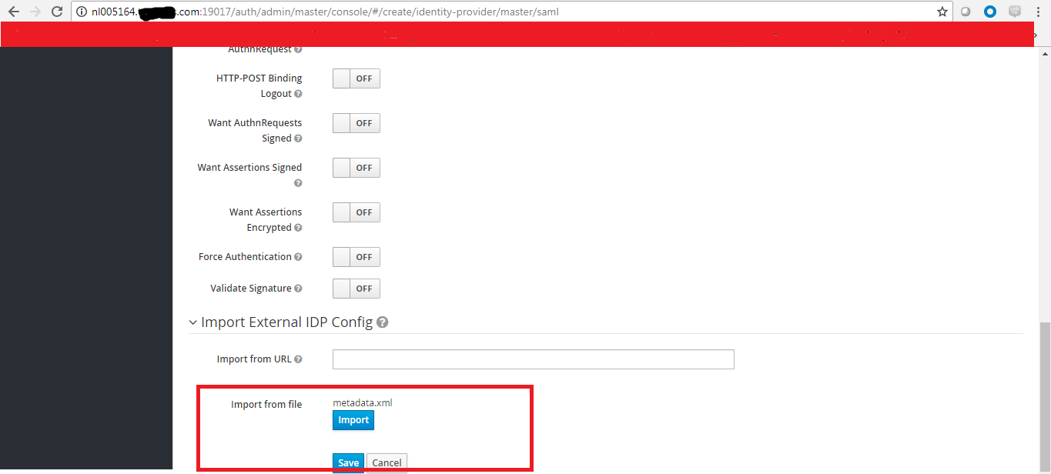

11)After importing the IDP metadata file logout from keycloak and a tab on the name of Saml-sample-app display on UI page of keycloak
Note : “Saml-sample-app” tab name can be changed as per our customization name under
Identityt provider-> alias name
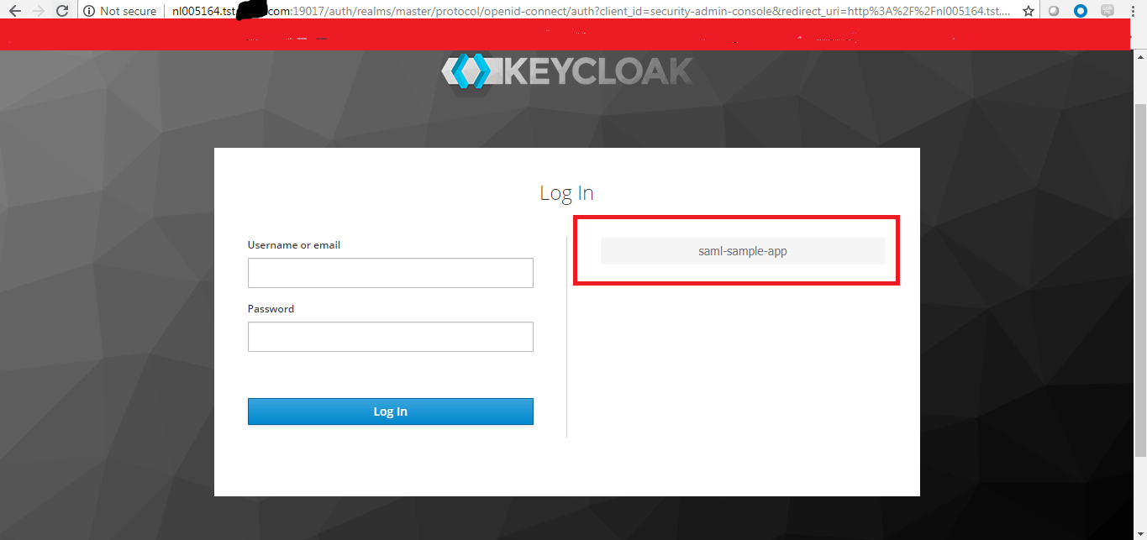
12)click on the tab “ Saml-sample-app” and it redirects to registration page for the first time users .Where we can register with our credentials

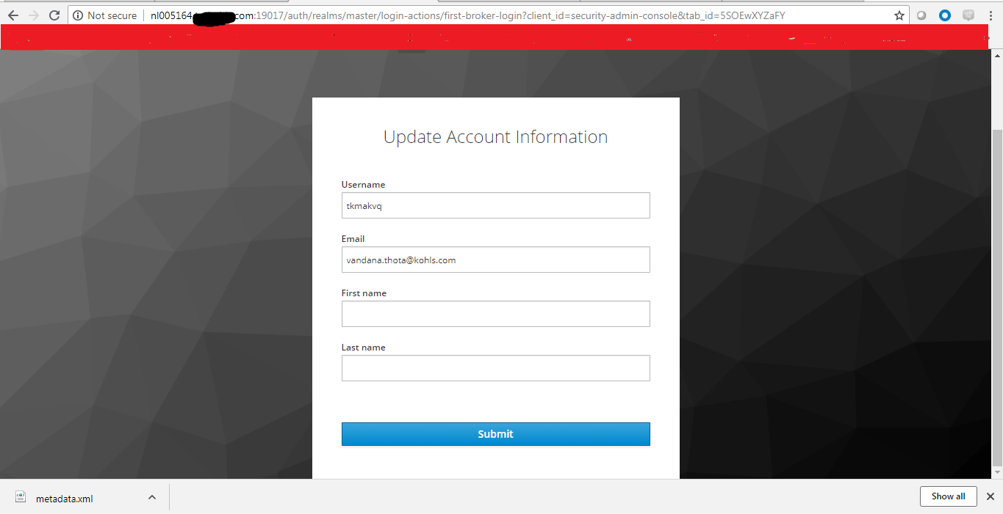

13)come back to keycloak page and click on Saml-Sample-app tab . It redirects to OKTA page . Provide the credentials with which we registered in the okta
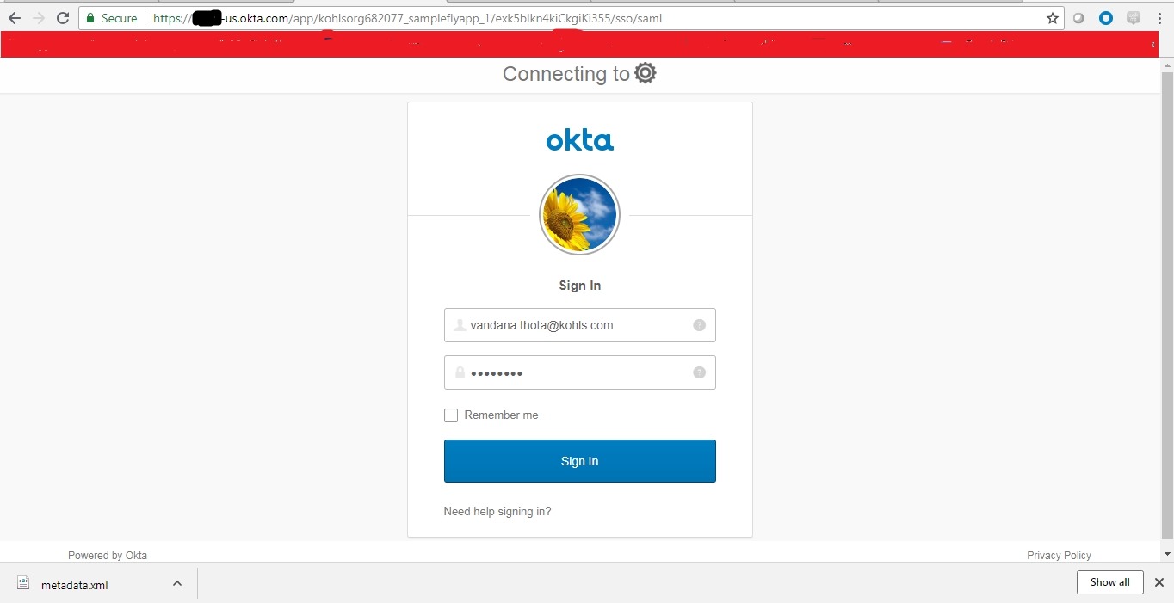

14)After sign in page it redirecting to Forbidden page (Issue 1: This can be resolved by having groups , Users roles etc defined in keycloak . It was successful in one sceanario.

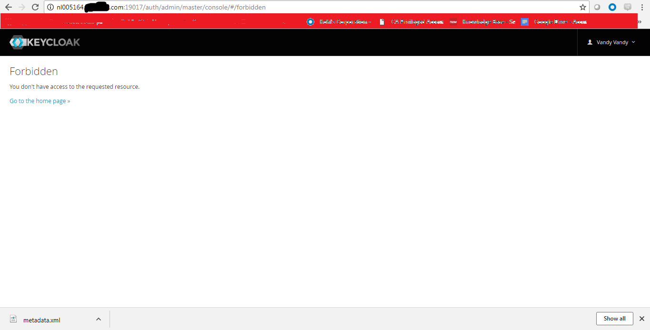

After above configuration
Scenario 1 :
Step 1 ) Login to page https://kohls-us.okta.com/
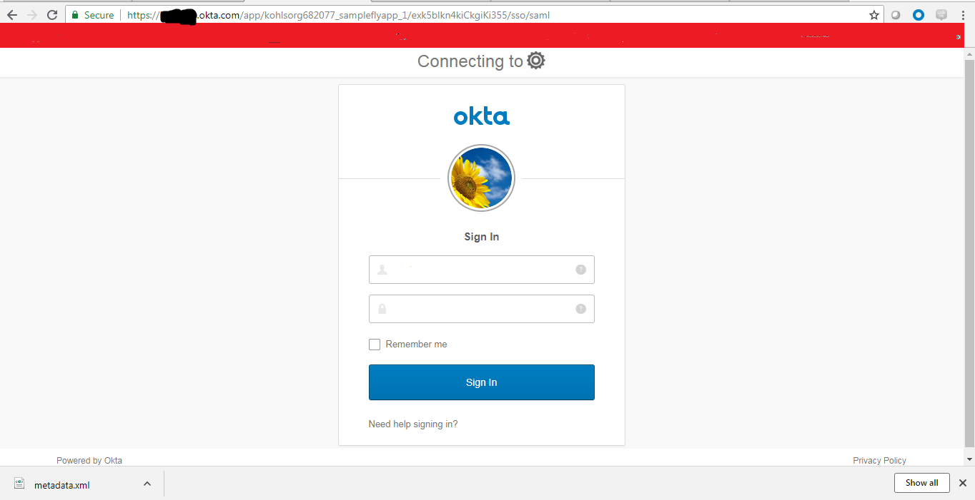
Step 2 ) Select Sample-fly-app
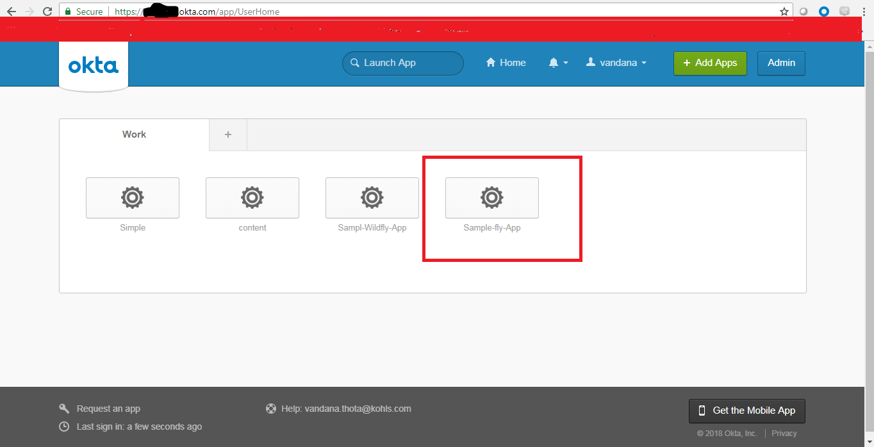
Step 3 ) Redirecting to error page on keycloak this is because we used the redirect url of keycloak and configured in okta . (ISSUE 2 )

Redirect url is automatic generated one and we can not able to change it as per our customizations
Redirect url
http://nl005164.tst.kohls.com:19017/auth/realms/master/broker/saml-sample-app/endpoint

